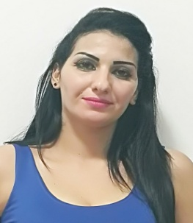
Soumia
Email: soumia.370354@2freemail.com
Education: Ibn al-Khatib, Rabat, Morocco
2000-2002 Bachelor in Arabic Literature

Experience:
Student Library Sale, Rabat
Position : Associate Supervisor
2004-2005
- Worked as Writing Associate for Curriculum Vitae in Arabic & French for students & locals working knowledge of MS word & Office
- Worked on photocopy & scanner machine for library documentation
- Issuing & Selling books to the students on daily basis

Sofarel, Sale, Rabat Position : Associate Helper
2005-2006
- Worked as tailoring associate in cloth company Sofarel got 12 Months vocational diploma in tailoring & Separation
- Ironing / Sewing & repairing of Clothes

Aswaaq Salam Supermarket, Rabat Position :Sale Person
2006 : 6 Months

- Welcome customers as they enter the store and inquire into their purpose of visit
- Demonstrate features of products of interest and provide information regarding pricing
- Provide information regarding products of choice and lead customers to the right shelves / aisles

Babysitting : Rabat
2006 : 3 Months
- Provide child care for several families, take care of kids when parents go leave for office
Achievements
- While Working in library owner give me full responsibility & every work top to bottom
Volunteer Experience
- Worked as Cooker in restaurant near home town in Sale Rabat specialty cuisine : Moroccan
Interests / Activities

- Play Football, Internet Surfing ,Cooking, Watching TV
- Writing Arabic Poetry & Daily dairy
Computer Skills
- Proficient with Microsoft Office, Internet, and Social Media
Language
- Arabic ,French : Proficient and English : Beginner Level

