SHAHRZAD
shahrzad.370372@2freemail.com
PROFILE IN BRIEF
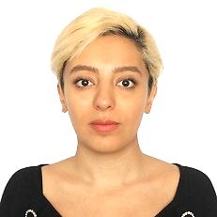

Civil engineer with experience and skilled in AutoCAD, Microsoft Excel, Microsoft Word, Microsoft PowerPoint, and Communication. Strong education professional with a TTC focused in teaching from ertebatat group.
EXPERIENCE AND CORE COMPETENCIES
- Quantity Surveyor | - AutoCAD | - Assist Project Managers
- Modeling  - Designing  - Categorize design drawings | - Site engineering  - Communication skills  - Team work  - Organization skills | - Internet ability  - Windows7,8,Xp  - Microsoft Excel  - Microsoft Office
PROFESSIONAL EXPERIENCE SUMMARY

Internet advertising structural engineer

tehran ,cobiax company january2015
    - Meet the advertising objectives initiated by the higher management.
    - Developing marketing campaigns to promote a product, service or idea.
    - Managing the production of marketing materials, including leaflets, posters, banners,
flyers, newsletters, e-newsletters, SMS marketing and Corporate DVDs.
    - Communicating with production and with clients about requirements and making
quotation for clients.
    - Coordinate with production to get finish product and deliver to client.
    - Liaising with designers for the concepts of designs as per branding guidelines.
    - Developing branding guidelines for new clients.
    - Developing and managing social marketing campaigns on Twitter, Facebook, LinkedIn,
you tube and other online advertising concepts.
    - Liaising with designer for the concepts of websites as per business objectives of clients.
    - Arranging media booking for clients.
    - Contribute to marketing team brainstorming/creative thinking to identify new marketing and advertising opportunities.
    - Analyze the results and consult with higher management.

Professional Qualification
Qualification  Bachelor degree  Civil Technology Engineering  Construction | Institution  Ghiyassodin Jamshid Kashani University (IRAN)
Associate of Generality Construction Works, Civil Engineering  College | SARIYAN UNIVERSITY(IRAN) 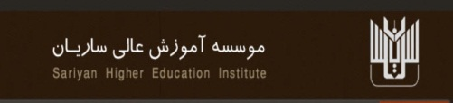  TAGHAVI EDUCATION CENTER (IRAN)
HSC (Mathematics & Physics) | Hejab high school (Iran)

SKILLS SET KNOWLEDGE AND COMPETENCIES

- Iran civil engineering license
- Familiar to the methods of construction lightening
- Auto cad
- Microsoft office
- Open minded and able to work in complex projects and environment
- Work Attitude Team player
- Excellent communication

PERSONAL DATA

Date of Birth: 19 September1989
Nationality: Iranian
Marital Status: Single
Languages: English (Fluent), Persian (Native), Arabic (Reading)
Driving License: International
AVAILABITLITY

Immediate

