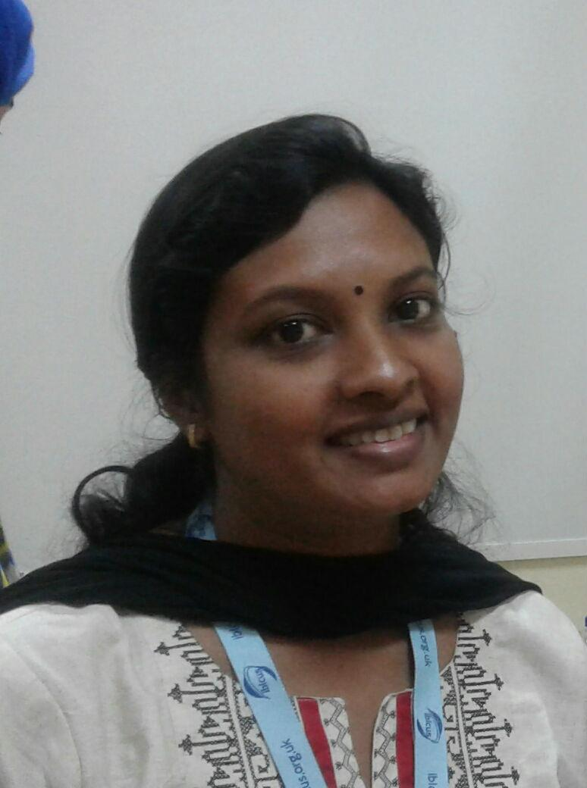Teresa

E-Mail: Teresa.370375@2freemail.com

LIBRARY AND INFORMATION SCIENCE PROFESSIONAL
LIBRARIAN

Passionate advocate of reading and literacy in all forms.I strongly believe that the library is the heart of the school, a place where students and staff engage in learning experience to evolve high level critical and creative thinking skills and as a librarian I ensure this happens in the library. Basically a hard worker enjoys taking up new challenges, e.g., setting up or revamping the library, initiating new activities to promote reading in the library.
P R O F I L E S U M M A R Y

Worked as an IB Librarian in an IB WORLD SCHOOL which is also affiliated to Cambridge board (IGCSE & A LEVELS) . I also have teaching experience, and has worked as a teacher, undergone child care training for child care professionals from the Department of Children and Families, Florida, United States of America.

Since I have worked as a librarian and as a teacher I kind of understand the teacher’s and the student’s perspective of what kind of information is needed for them to bring learning outcomes.

Also a Member of CILIP (Chartered Institute of Library and Information Professionals, United Kingdom) membership number 10045157, pursuing a Certification course from CILIP

Presently working as a learning resource specialist in Gems millennium school, Sharjah. Promoting the use of the

library as essential to the learning targets of the school. By participating fully in the life of the school through

regular meetings with teaching and management staff. Responsibilities include

O R G A N I S A T I O N A L E X P E R I E N C E

GEMS Millennium School, Sharjah, UAE Present

Main Duties Performed:

- Providing support and any resources needed for students

- Guiding students and staff on how to utilise the new electronic check-out machines in the library

- Conducting reading sessions and library classes for K-12

- Guiding staff on where to find resources for curriculum support.

- Continually cataloguing, labelling and adding new books, CDs and DVDs to the library system both physically and electronically.

- Teaching information literacy skills, and encouraging and assessing reader development through activities appropriate for targeted age group of students

- Sometimes even being responsible for the virtual learning environment.

- Assisting the students to acquire authenticated information for research and also providing assistance in citation

Dr. Pillai Global Academy, Navi Mumbai, | 2014-2016
Main Duties Performed:

- Is familiar with all the curriculum documentation, and where they can be accessed.

- Developing and managing collections of books and journals (both paper and electronic), as well as websites.

- Establishing and maintaining effective working relationships with academic staff and students

- Contributing to academic course development and liaising with academic departments.

- Coordinating and delivering information and digital literacy sessions to staff and students

- Creating, updating and managing electronic and printed information resources

- Selecting, acquiring and cataloguing information using library and information software.

- Assisting researchers with literature searches using databases, printed resources and the internet;

- Managing and supporting the provision of reading lists and allocating length of loans

- Dealing with user enquiries, which may involve one-on-one advice sessions

- Dealing with budgets in relation to your allocated subject areas/departments and, in some cases, purchasing resource.

- Keeping up to date with relevant professional developments in the library sector

- Participating in professional groups or networks.

▪  Assisting staff and students to follow Academic reference style.

- Promoting Citation Generators and Plagiarism detectors as tools for further learning.

P R E V I O U S E X P E R I E N C E

Veronica Pre- Primary School, Navi Mumbai, | 2013-2014
Teacher
Tropical Grand Vacations, Florida, USA | 2006-2008
Customer Service Manager
St. Xavier’s English School, Thane | 1997-2000
Teacher
A C A D E M I C D E T A I L S

- Masters In Library and Information Science (M Lib) from Bharati Vidyapeeth ,Pune University, Pune in 2015

- Associate Degree in Child Care Development (CDAE) from Department of Children’s & Families, Florida, USA in 2007
- Bachelor’s Degree in Library and Information Science(B. Lib), from Mumbai University, Mumbai in 2001

- Bachelor’s Degree in Arts (Economics), from Mumbai University, Mumbai in 1996

T R A I N I N G P R O G R A M M E S A T T E N D E D

- Completed 40 Hrs. US State Mandated Child Professional Training from the Department of Children’s & Families, Florida USA in 2007
- Attended the IB Diploma Programme category 1 workshop for IB Librarians which was held in Dubai -2015

I T S K I L L S

- Knowledge of MS Office (PowerPoint, Excel & Word), also worked in SOUL a Library Management Software

 | P E R S O N A L D E T A I L S
Date of Birth: | January 16th 1976
Languages Known: | English, Hindi, Marathi, Malayalam

