MUHAMMAD
Email: Muhammad.370383@2freemail.com

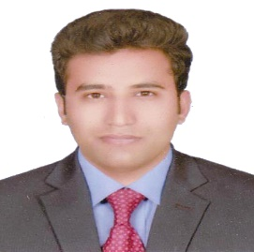
Performance Summary:
Highly industrious Electrical Worker with 1 years’ experience in Pakistan and handling different types of Electrical Steam Power Station, Combine Cycle, Diesel Power Plant, Maintenance and Operation System With SPS, using good experience and great attention to detail. Highly proficient in Diesel Power Plant, Steam Power Plant, Combine Cycle and site preparation. A proven team player who has a profound ability to communicate at all levels of managers and coworkers. Expert in interpreting blue prints and executing Electrical plans. Effectively prioritize tasks and manages time to meet strict deadlines.

Education
- BSc Electrical Engineering Technology Year 2016
(G.C University Faisalabad)

- DAE Electronics Year 2011
(Punjab Board of Technical Education)

- MATRIC Year 2008
(BISE FAISALABAD)
Electrical Courses:
Electrical Machine, Power Generation and Utilization, Power transmission Technique, Measurement and Instrumentation, Power Plant Technology, Electrification and Energy Auditing, Power System Protection Techniques, Industrial and Power Electronics, Renewable Energy Technology, High Voltage Technology, Principal Of Electrical Engineering, Computer Networking.

Areas of Expertise & Professional Experience
COMPANY  WORK EXPERIENCE: | North Power Generation Company Limited  Government Management & Power Corporation - Genco-3, Faisalabad  - Works As Trainee Electrical Engineer

Skills
- 3rd Position Traffic Control Project
- Proficiency English and Urdu
- Believes in Team Management
- Tool and Safety Technique
Computer Skills
- Microsoft Office 2013
- Computer Networking

Personal Detail

- Date of Birth: 31-03-1993
- Gender: Male
- Material Status: Single
- Nationality: Pakistani
- Religion: Islam
Reference

Pertinent references can be furnished upon request

