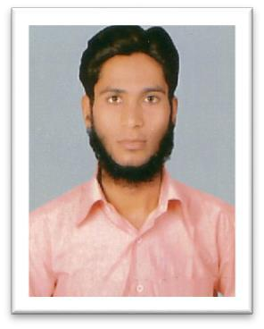
Curriculum Vitae

KHAJA

Email: khaja.370405@2freemail.com

Career Objective:

Seeking a challenging career in an organization that offers opportunity to use my experience, knowledge and capability, enhancing development and personal growth, and enabling me to contribute positively towards the organization growth.

Academic Qualifications:

B.Com (Comp) | : Osmania University (Hyderabad)
MBA (Finance) | : Candidate (Sikkim Maniple University)
Computer Skills:
Accounting Application | Tally ERP 9,
Application Software | MS OFFICE ( Word, Excel, PowerPoint ),
Work Experience:
Organization | : Etisalat
Period | : 12/05/2016 till date
Job Title | : Sales Executive

Roles & Responsibilities :
- Sold data and voice services to walking customers

- Adding packages and changing numbers from prepaid to postpaid

- Assist customers in amending their existing account numbers

- Attempting to resolve all enquires on first contact with the customers.

- Good keyboard skills and excellent communication skills.

- Helping our existing customers to renew their packages and handling objections

- Good knowledge of phones

Organization : Royal Sporting House L.L.C (Abu Dhabi)

Period : May 2015 to May 2016

Job Title : Customer service associate

Roles & Responsibilities :
- Store in charge

- Visual merchandising

- Attending customers, Hardcore selling/electronic massage chair

- Making sales report on daily basis

- Sending mails to branch manager about individual sales
- Follow up with customer request through call

Organization : Magic Holiday

Period : Feb 2013 to Feb 2015

Job Title : Tele Sales Executive

Roles & Responsibilities :

- Serves as a basic point of contact for customers with complaints, queries, request, feedbacks etc.

- Ensures that all the request, queries and complaint of customer are responded in a timely and professional manner
- Develops as well as maintains the relationship with external parties

- Responsible for proper scrutiny and recording of the complaints received from customers

- Conducts research and complies answers for informational request from external customers

Organization : HSBC Accommodation

Period : Jan 2012- Jan 2013

Job Title : Front office assistant.

Roles & Responsibilities :
- Welcome visitors and guests and direct appropriately.

- Arranging maintenance visits and logging the duration thereof.

- Record and handle all incoming and outgoing couriers.

- Provide word-processing and secretarial support

- Assist in the planning and preparation of meetings, conferences and conference telephone calls.

Personal Profile:

Name : KHAJA

Marital Status : Single

Date of Birth : 16-April-1989

Religion : Islam

Nationality : Indian

Linguistic Proficiency : English, Hindi, Urdu, & Telugu.

