CURRICULUM VITAE
[PHARMACIST]
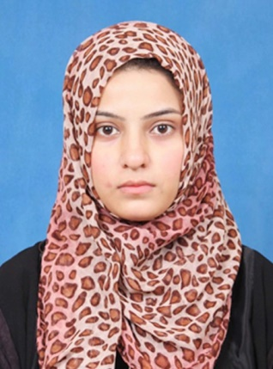
NEELAM.370447@2freemail.com
[Email]

dR. neelam
Objective |  | Licensed Pharmacist With Pham-D Degree, Want To Work In A Reputable Organization Where I Can Polish My Abilities As A Hospital/Community Pharmacist By One To One Interaction With Patients, Where I Can Get A Grip On All Activities Going On In A Pharmacy, Want To Participate In Programmes Serving Humanity On Behalf Of Organization I Work In Because Want To Get Myself At A Appoint Of Zenith Of Being A Real Human Than Being An Employee Only. Ultimately My Achievement Will Be The Achievement Of The Organization As We Both Aim At Serving The Humanity.
Skills & Abilities  OTHER SKILLS |  | Able To Communicate Well With My Peers To Maintain Good And Friendly Professional Relationships, Can Adapt Myself To The Dynamic Environment, Know My Professional Boundaries, Hardworking And Enthusiastic To Face New Challenges And Experiences, Product Safety And Quality Assurance, Patient Education And Counseling On Common Diseases And Hygiene Maintenance.  Able To Use MS Office, Adobe Photoshop, Corel Draw, Can Communicate Fluently In Local Languages E.G., Pothohari, Punjabi To Facilitate Illiterate Patients And Also Urdu And English With Good Proficiency.
education |  | matriculation/SSC  VIQAR UN NISA NOON GIRLS HIGHER SECONDARY INSTITUTE , JEHANGIR ROAD RAWALPINDI.(JULY 2005)  MARKS-710/850(GRADE-A+)  HSSC(PRE-MEDICAL)  SIR SYED SCIENCE COLLEGE FOR GIRLS, TIPU ROAD,RAWALPINDI.(AUGUST 2007)  MARKS-839/1100(GRADE-A)  PHARM-D  RIPHAH INSTITUTE OF PHARMACEUTICAL SCIENCES ISLAMABAD(2008-2013)  CGPA-3.70  COURSE:  - BASIC LIFE SUPPORT (BLS)(SEP 2014)  SHIFA INTERNATIONAL HOSPITAL, ISLAMABAD.  As A Health Care Professional This Course Provided Me The Ability To Recognize Several Life-Threatening Emergencies, Provide CPR, Use An AED, And Relieve Choking In A Safe, Timely And Effective Manner.  LICENSING EXAM:  - SAUDI LICENSING EXAM(PHARMACY SPECIALIST)(MARCH 7,2016).  - MINISTRY OF HEALTH-UAE[PHARMACY SPECIALIST] [MAY 3,2017].
EXPERIENCE |  | JOB AS A HOSPITAL PHARMACIST(AUGUST 2013- JUNE 2017)  HAMID HOSPITAL,GUJAR KHAN, PAKISTAN  Dispensing, Patient Counseling, Inventory Management, Supervising Junior Staff, Expiry Date Checking, Ensuring Appropriate Storage Of Medicines And Documentation.  INTERNSHIP AT ISLAMIC INTERNATIONAL MEDICAL TRUST(RAILWAY HOSPITAL)(FEB 2012-JUN 2013)  RAILWAY HOSPITAL, RAWALPINDI,  Patient Counseling, Adverse Effect Monitoring, Dispensing, Ward Inspection, Pharmacist Workup Of Therapy, Designing Pharmaceutical Care Plan (PCP).  INTERNSHIP FOR COMMUNITY PHARMACY(FEB 2011-JUN 2011)  KRL GENERAL HOSPITAL ISLAMABAD  Stock Taking And Shelving, Dispensing Of Medicines, Prescription Evaluation.
PERSONAL INFORMATION  NOTE |  | - NATIONALITY PAKISTANI  - DATE OF BIRTH 07 SEP 1988  - MARITAL STATUS MARRIED  - LANGUAGE ENGLISH, URDU,POTHOHARI,PUNJABI  DOCUMENTS ARE ATTESTED FROM HIGHER EDUCATION  COMMISSION PAKISTAN, FOREIGN AFFAIR AND UAE EMBASSY .

