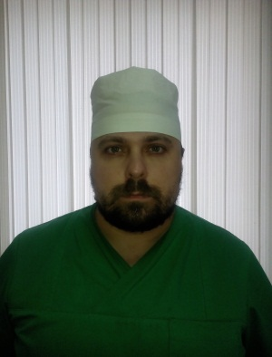
Artur
Artur.370467@2freemail.com

Position applied for: | Contaminated Surgery Specialist  Surgery Specialist
 | Traumatology Specialist

PERSONAL DATA
First and last name | Artur
Nationality | Belarus
Country & city of residence | Belarus, Rogachev
Date and place of birth |  | 31/07/1983. Belarus, Vitebsk
Marital Status / Children |  | Married\1 child

EDUCATION | Specialization | Duration | Year of graduation/City/ Country
Vitebsk State Order of Peoples’ Friendship Medical University | Medical Doctor, General Surgery | 6 years | 2001/09 -2007/06  Vitebsk, Belarus
Gomel State Medical University | General surgery residency | 1 year | 2001/08 - 2002/08  Gomel, Belarus
Belarusian Medical Academy of Post-Graduate  Education | Advanced courses in Traumatology and orthopedics for traumatologists-orthopedists | 4 months | 2014/02 -2014/05  Minsk, Belarus

WORK EXPERIENCE 10 years totally
Position | General surgeon
Company’s name | Polyclinic of Rogachev regional Hospital,
Period/City/Country | 12/08/2008-19/12/2011, Rogachev/Republic of Belarus
Position | General surgeon
Company’s name | Rogachev regional Hospital, Department of purulent surgery
Period / City / Country | Since 19/12/2011– 13/02/2013 Rogachev/Republic of Belarus
Position | Chief of Department
Company’s name | Rogachev regional Hospital, Department of contaminated surgery
Period / City / Country | Since 13/02/2013-14/01/2017 Rogachev, Belarus
Position | General surgeon
Company’s name | Vitebsk Regional Clinical Hospital
Period/City/Country | 4/04/2017 Vitebsk/Republic of Belarus
Responsibilities | Major activities:  Providing treatment and surgical interventions in such sectors of surgery and trauma, as:  Contomitant Injury and Surgery, Traumatology, Urgent Neurosurgery for Adults and Children (trepanations of scull, evacuation of subdural, epidural and intracerebral gematoms), Treatment and Autodermoplasty of Burns, Urgent Thoracic Surgery, Urgent Abdominal Surgery, Urgent Angiosurgery (blind embolectomy, vascular suture), Urology.  Organising the Department in Hospital.

Special courses
Date |  | Name of school | Course title
28/10/2008 | 11/11/2008 | Belarusian Medical Academy of Post-Graduate Education  Minsk/ Belarus | Outpatient  Traumatology  Advanced professional course
24/11/2008 | 5/12/2008 | Belarusian Medical Academy of Post-Graduate Education  Minsk/ Belarus | Modern Technologies in Surgical Practice  Basics of Minimally Invasive Surgery  Advanced professional course
18/04/2011 | 24/04/2011 | Belarusian Medical Academy of Post-Graduate Education  Minsk/ Belarus | Modern Technologies in Surgical Practice  Surgical Treatment of Gastric Ulcer and Duodenal Ulcer
19/09/2011 | 30/09/2011 | Belarusian Medical Academy of Post-Graduate Education  Minsk/ Belarus | Modern Technologies in Surgical Practice  Infection in Surgery
21/12/2007 | 23/12/2007 | Institute of surgery  Named after A. М. Vishnevsky, Russian Federation, Moscow | High-tech methods of diagnosis and treatment in abdominal surgery  International Conference
English: -Good, can have a basic discussion

Current position: general surgeon in Department of Contaminated Surgery in Vitebsk Regional Clinical Hospital.

