CURRICULUM VITAE
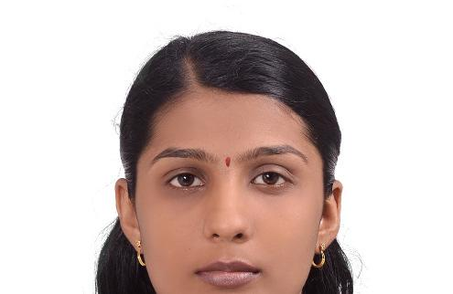

Nisha
nisha.370495@2freemail.com

Career Objective:

To secure a challenging position where I can effectively contribute my skills as Software Professional, possessing competent Technical Skills.

Experience: 1 year 5 months in Mainframe at MindTree Private Ltd, Bangalore.

Professional Experience

Project Team: AMEX-Globestar Production Support

Client Name: American Express (AMeX)

Duration: July 2011 -December 2012

Description of the project:

American Express is a leading global payments, network and travel company, backed by one of the world's most recognized brands. American Express is unique in the payments industry as an issuer of cards as well as a worldwide network that processes millions of merchant transactions daily. Amex offers the broadest array of charge, credit, prepaid and co brand cards for consumers, small businesses, midsize companies and large corporations. The objective of the project is providing Production support to Amex involving both Batch and application support and Maintenance to keep the business as usual from Globe star point of view.

Role: Team member (Production Support)

Responsibility: Resolving production abends, Root cause analysis of issues and providing permanent fix to the issues.

HARDWARE: OS/390

SOFTWARE/TOOLS:

IBMOS390,MSWord,MSExcel,Cobol,JCL,VSAM,FileAid,Changeman,Infoman,Abendaid,

Manage Now, Control-M, Jobtrac.

Educational Qualifications:

Examination | Discipline/ | School/college | Board/ | Year of | %
 | Specialization |  | University | Passing
 | Computer | LBSITW, | Kerala University |  | 65.5%
B. Tech | Engineering | Trivandrum |  | 2010
 |  | Jyothinilayam
+2 | Biology | EMHS, | HSE | 2005 | 81.3%
 |  | Trivandrum
SSLC |  | Al-Uthuman EMHS | State | 2003 | 75.6%
 |  | Trivandrum
Computer Skills:
Languages | : C, C++, COBOL, JCL
Database | : SQL, ORACLE, VSAM, DB2

Operating Systems : Windows 9X/2000/XP, DOS 6.0.

Courses:

Completed IBM Mainframe course from C-DAC (2011)

Completed Oracle certified DBA Course from Pinnacle (2013)

Academic Project

Project1: | Student Management System
Language of Implementation: |  | JAVA
Operating System:Windows03

DESCRIPTION:

Student Management System commonly used in professional colleges .For this there are two modules-Administrator & student. It is fully automated and there is only less time consuming. Only administrator is allowed to configure the system. Staff in charge is the user who is supposed to enter the database needed for our automated system. Strong authentication & authorization mechanism avoids unauthorized access and fraudulence with the data. Here include the details of student’s biodata and marks the student can only view his/her detail when sign in through his/her name & password.

Project2: Alumni Website

Language of Implementation: ASP .NET
Operating System: Windows03

DESCRIPTION:

Alumni on the Web come with all of the features needed to keep your alumni in constant contact with

fellow alumni and your organization. Alumni on the Web are a full featured social and professional

networking solution for your alumni. The website features detailed user profiles, and alumni database,

news, career center, professional directory, events calendar with registration, photo gallery, memorials,

donation integration, group pages, and much more.

Personal Profile:
Name | : | Nisha
Father’s Name | : | George Pereira.
Husband Name | : | Praveen Stanley Simon.
Sex | : | Female
Marital Status | : | Married.
Visa Status | : | On Husband Visa.
Nationality | : | Indian
Hobbies | : | Reading, Dancing, Cooking and Singing.

Declaration:

I hereby declare that the above-mentioned information is correct up to my knowledge and I bear the responsibility for the correctness of the above-mentioned particulars.

Place: Dubai.

Date: 30 / 09 /2014 .

