RESUME
ABBURI | 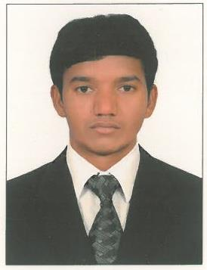
 | email : abburi.370500@2freemail.com

OBJECTIVE
Seeking a challenging and rewarding opportunity with a reputed organization which recognizes my true potential while nurturing my analytical and technical skills. Anticipating a position in which my experience can be a positive influence on the growth of company.
PROFILE
- Competent, diligent and result-oriented professional, having an inborn quantitative aptitude & determined to carve a successful and satisfying career in the industry.
- Good organizational skills and time management skills.
- Energetic and capable of working independently and a good deal of autonomy.
- Proficient typing skills, computer skills and knowledge of relevant software packages.
Work Experience
- DUTCO BALFOUR BEATTY, DUBAI, UAE.
  - Data Entry Operator (From 01st September 2016 to Present)
    - Preparing reports for all material deliveries such as concrete, rocks and assisting the commercial department with accurate cost reports.
    - Collaborated with various departments and offices for all activities and ensured efficiency.
- ADDS, Telangana, India.
    - Making Shop Ads, Birthday, Ads, Festival Ads etc.
ACADEMIC QUALIFICATION
Course | Institution | Board Of Study  /University | Year of completion
12th (Intermediate) | Narendhera Co-Junior College  Metpally. (Karimnagar Dist.) | State board of Telangana | 2016
10th  (SSC) | Sri Sai Chaithanya high School e/m  Metpally. (Karimnagar Dist.) | State board of Telangana | 2014

Computer Skills
- M.S Office (Word, Excel & Power point), internet browsing & email.
- Operating Systems: Win 98 & XP.
Interests & Hobbies
- Sports – Cricket, Chess & Volley Ball
- Reading Books, Writing Poems, Watching
Added Credentials & Strong Areas
- Confidentiality & Creative thinking
- Receptive to guideline from senior professionals
- Teaming up with the colleagues
- Optimistic in nature
Present Address
RANADEEP ,

Personal Particulars

Date of Birth : 05/03/1996
Marital status : Single
Sex : Male
Nationality : Indian
Languages known : English, Telugu (Read/Write-Fluent)
: Hindi (Moderate level)

DECLARATION:
I hereby declare that the above mentioned particulars are correct and complete to the best of my knowledge.
Place : Dubai

