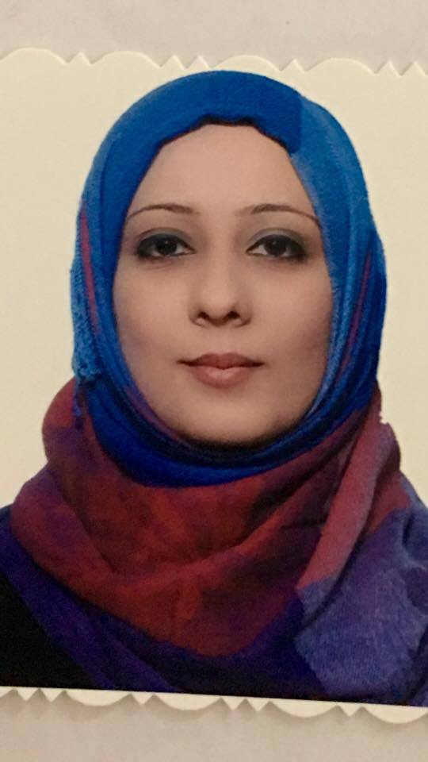

Rua
RUA
Email: rua.370518@2freemail.com
Personal Data:
Date of birth: 4/11/1984
Place of birth: Iraq-Dywania
Citizenship: Iraqi
Marital status: single
Languages: English & Arabic
Job description : Emergency medicine specialist

EDUCATION:
*Jordanian Board of accidents and emergency medicine on 27/9/2016
*M.B.CH.B degree in medicine and surgery on 10/7/2008 from Kufa university in Iraq
Experience:
_Total work experiences : 8ys +8 months
_Emergency accident and disaster management and massive causalities experiences : 7yr +5 months
_ New intern on 18/1/2009 till 11/3/2010 in Najaf city in Iraq as regular resident between 3 hospitals include medicine, surgery ,pediatrics ,gynecology branches.
_Rural doctor on 11/3/2010 till 6/9/2010 in Al manathera hospital in Najaf
_Senior house officer of emergency medicine on 6/9/2010 in Al sader medical city in najaf
_Senior resident in program of Arab Board of emergency medicine for four years in medical city in Baghdad on 11/12/2011 till 7/9/2016
_Senior specialist in al sader medical city (teaching hospital) in Najaf on 18/9/2016
_participate in training of new collage nurses in Al sader medical city by dolls .
Certificates:
-Emergency services and trauma management course for doctors by ICRC (international committee of Red Cross ) on 19 September to 7 October 2010
-Two certificates from American Heart Association on 24/4/2011 and 8/5/2017 ( ACLS and BLS course)
Awards:
Appreciation letter from Kufa university /collage of medicine to help in training of medical student in ACLS course on 8-10 may 2017.
Key Skills:
Patience, Loyal and disciplined towards duties.
Hard worker even in loaded environment. .
.Good knowledge of medical equipments like CV line
Chest tube ,intubation ….etc.
*All of the above are supported by documents , you can get it at any time.

