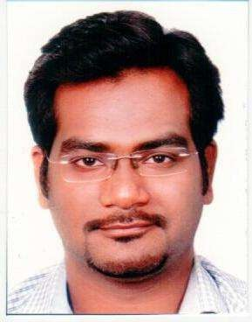
Sameer
Email: Sameer.370521@2freemail.com

Seeking a responsible and challenging position in a growth oriented progressive Institution where my experience and skills will significantly contribute to the overall success of the organization and provide opportunities for my career growth.

Organization Experience:

ALTISOURCE BUSSINESS SOLUTIONS (SEP 12th 2011 to OCT 8th 2012)

Associate in Mortgage Back Office

• Renewing insurance policies of the insured person.
• To maintain insurance policies.
• Cancelation of policies.
• Also reinstate insurance with lapse or without lapse.
• Also to call agents of the insured, if the insurance amount is not clear in our records.
• Working on separate queues (Faxes).

Travelguru Pvt Ltd (Jan 2013 to April 2014) Client Relations Executive.
• Worked as a Service Executive in Hotel helpdesk department of the hotel team.
• Solved a lot of different types queries of passengers via mails and calls pertaining to changes in itinerary, cancellations and also new bookings.
• Also use to co-ordinate with travel agents and corporate clients for the same.
• Used to always achieve my targets efficiently and also used to be appreciated for the same.
• Have also received training for customer handling.

Ocwen Financial Services Ltd (Sept 2014 - Aug 2015)

• Worked as Quality analyst for underwriter Department.
• Worked for Loss Mitigation Department (US Mortgage process).
• Worked for HAMP, NON HAMP and Haup loan
• Review the file of the underwriter and give them feedback on email and coach them accordingly.
• Based on the review, we as quality analyst give final decision to the loan for approval or denial.
• Quality was based on critical and non - critical parameter.
• QC for the underwriter was being done end to end.
DESIYA ONLINE/YATRA PRIVATE LIMITED. (Sept 2015 to Aug 2016) Customer Service Executive (B2B Clients)
• Handling inbound calls & Emails related to the Queries of the Guest as well as the Hotelier.
• Handling Post Sales Issues, Queries Feedback & Complaint of the Direct Customer.
• Assisting the Guest / Hotelier with the best possible solution & assist with an Immediate assistance over the call itself.

COGNIZANT SOLUTION PVT LTD. (01st Sept 2016 to 18th May 2017) Senior process executive
• Worked for loss mitigation process (US Mortgage Process)
• Worked for Private, FHA, Freddie/ Fannie loans and based on the hardship, Loan modification was given to the borrower.
• Loan Modification was mainly calculated on 2 documents Income and Expense Statement of the borrower.
• Once we get the require documents from the borrower we forward the loan to the Underwriter for further review.
• Loan has to be completed in given SLA provided by the client.
• Loan classification was handled by me.

Education:
• | 2010: | BMS (Bachelor in Management Studies)
• | 2007: | HSC
• | 2005: | SSC
Personal Details:

Date of Birth : 14th Oct 1989
Languages known : English, Hindi & Marathi
Religion : Roman Catholic
Visa Status : Visit Visa (Expiry on 16th July 2017).

SAMEER

