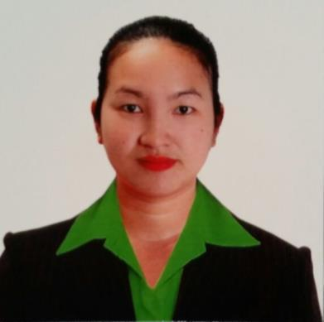
BERNADETH

Email Address: bernadeth.370522@2freemail.com

Visa validity: August 12, 2017

Career Objective:

To expand my knowledge and skills beyond limit and to be a responsible Filipino citizen.

Work History

DAR Optics Company
Sales Staff / Cashier
Al Hamra Mall Ras Al Khaima, UAE

November, 2010 – November 2013

Duties and Responsibilities

Assisting costumers in terms of understanding their needs Preparation of weekly / monthly target report

Keeping target sales always on track

Keeping all items in clean and neat condition

Preparation of inventory and sending reports at main office in weekly basis

PONDS UNILIVER PHILIPPINES

Beauty Adviser

Trinoma Mall, Quezon City, Philippines April, 2010 – Sept, 2010

Duties and Responsibilities

Assisting costumers and advising beauty tips depending on their needs Preparation of weekly / monthly target report

Keeping target sales always on track

Keeping all items in clean and neat condition

Preparation of inventory and sending reports at main office in weekly basis

Philips Gadgets and Accessories
Sales Staff
Greenbelt 1, Ayala Mall, Philippines

November, 2008 – March, 2010

Duties and Responsibilities

Assisting costumers in terms of understanding their needs Preparation of weekly / monthly target report

Keeping target sales always on track

Keeping all items in clean and neat condition

Preparation of inventory and sending reports at main office in weekly basis

Goldway Digital Equipment Inc.
Sales Staff
Glorietta 4 Ayala Mall, Philippines

November, 2007 – October, 2008

Duties and Responsibilities

Assisting costumers in terms of understanding their needs Preparation of weekly / monthly target report

Keeping target sales always on track

Keeping all items in clean and neat condition

Preparation of inventory and sending reports at main office in weekly basis

PANCHO PAWNSHOP

Appraiser / Cashier Tondo, Manila, Philippines
May 2006 – September 2007

Duties and Responsibilities

Assisting costumers in terms of understanding their needs

Educational Attainment
High School Graduate

Natividad High School
Guagua Pampanga, Philippines

Personal Information

Date of birth | : | March 03, 1987
Place of birth | : | Philippines
Age | : | 30
Gender | : | Female
Height | : | 5’2”
Weight | : | 119 lbs
Citizenship | : | Filipino
Language spoken | : | English/Tagalog
Civil Status | : | Married

I hereby certify that the above information are true and correct to the best of my knowledge and belief.

BERNADETH

Applicant

