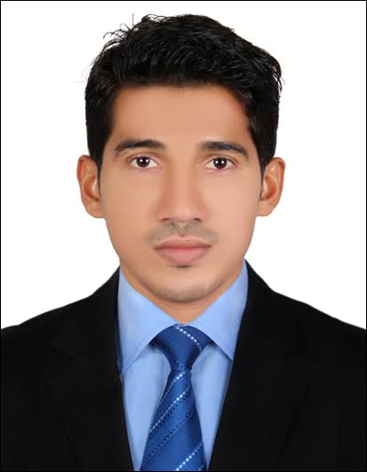
MOHAMMED
MOHAMMED.370540@2freemail.com

CAREER OBJECTIVE

Seeking a long-term position in an organisation that provides me an opportunity to utilise my education, knowledge and skills in the area of civil engineering, and benefits me to achieve self-objectives as well that of the organisation.

WORK EXPERIENCE

Worked as Site Engineer & Planning Engineer from JUNE 2015 to DECEMBER2016 in COASTAL CONSTRUCTION, Mangalore India.
ROLES AND RESPONSIBILITIES
- Undertaking inspections, data collection and supervising construction of work
- Preparation of drawings, reports and specifications.
- Estimate the quantity of raw materials, labor andequipments, electricity, etc. required for the project.
- Provide assistance to the seniors by supporting them in their routine duties
- Ensuring that all assigned work is completed on time and within agreed budget
- Contacted with clients to find out requirements of projects
- Prepare Daily report and attend weekly progress meetings

ACADEMIS

- Bachelor of Engineering (BE-CIVIL) from Sahyadri College of Engineering and Management, Mangalore, affiliated to Visvesvaraya Technological University (VTU), Karnataka, in 2015.
- Professional in Project Planning & Management using Primavera P6 Professional V8.2 ORACLE, from CADD center, Mangalore
- PUC KARNATAKA STATE : Thumbay Pre-University College
- SSLC KARNATAKA STATE : Thumbay High School

SKILLS

- Well versed with the civil engineering principles and methods.
- Ability to interpret information and communicate the details in writing and verbally.
- Good with numbers and statistics that help to calculate accurate measurements.

PROJECT WORK

COMPARITIVE STUDY OF NATURAL AND ALTERNATIVE FINE AGGREGATES.
Overview: This project aims at study of behavior of natural fine aggregates and replacing it with the alternative materials like quarry dust, plastic waste, GGBS etc.

WORKSHOP & SEMINAR

- Actively participated in Finishing school programme on “Building construction, supervision and management”
- Actively participated in Technical Exhibition conducted in Sahyadri College
- 15 days survey camp held in Koila village, Mangalore, India

PERSONAL DOSSIER

Date of Birth : 07th March,1993
Sex :Male
Nationality :Indian
Religion : Islam
Marital Status : Single
Languages :English, Hindi, Malayalam, Kannada and Tulu

I hereby declare that the above mentioned details are true to the best of my knowledge, information and belief.

