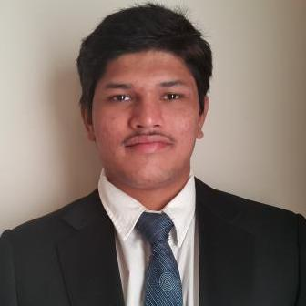
Avinash
Avinash.370541@2freemail.com
Dubai, United Arab Emirates
Contact Number:
Email Address:
Nationality:
Indian
Date of Birth:
Sponsorship/Visa:
Student Visa
Driving License/Car:
Yes / Yes

About Me
I am Avinash from India. At present I am doing event management course at EMDI, Dubai .I completed my BBA course in India. I also did adobe photo shop, after effects ,video adding. MY hobbies are photography, music, swimming, social network chatting particularly I am looking for an opportunity to work as part time or even voluntary work also anything related to events or graphic designing and I have 2 years experience in graphic and 1 year in event field

Education Details
University:
Degree Status:
Major :
Specialisation:
Graduation Date:
GPA or Expected:
Sunrise University
Bachelor`s Degree
Accounting
BBA
7/2016

Grade Details
Grading System:
Grading Format:
Percentage:
Percentage System
Percentage
70-79

Computer Skills
Proficiency in:
Adobe After Effects,Adobe Photoshop,Microsoft Excel

Skills
Proficiency in:
Education Management

Languages
Language
English
Spoken
Written
Read
Moderate
Moderate
Moderate

Activities and Achievements
Hobbies and Sports:
photography,music,swimming,social network chats

Additional Skills
Name of Institution/Organisation:
Certification:
Completion Year:
ARENA
Avinash Bolla
2015

Availability
Interested In:
Available Dates:
All Types
27/11/2016 to 01/01/2018

