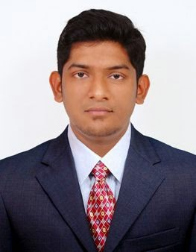
Mohamed
Mohamed.370553@2freemail.com

Objective
Mechanical engineering graduate with two years experience as sales Engineer and Assistant Manager, Currently pursuing MBA in Marketing Management in Distance education mode seeking a technical marketing position in a reputed company for a long run and development in career.

Key Qualifications
● Sales and Marketing
●Business Presentation
● Site evaluation
● Technical Advice
● Customer relationship

Work Experience
Sales Engineer [MARCH 2016 - PRESENT]
Sunbeam Generators Pvt Ltd [Kirloskar OEM], Pondicherry

●Handled Territory Sales and Marketing position. Planned and Executed Regular Client Visits.
●Acquired New clients and engaged in Product presentation , Negotiation and Pipelining
●Evaluated sites for technical calculation, recommendation and project execution.
Assistant Portfolio Manager [APRIL 2015- MARCH 2016]
Harvest Futures consultants India Pvt. Ltd.

● Portfolio management of client accounts in international Trade market
●Managing a team of 5 traders and training new employees.
●Regular interactions and presentations with clients on business progress

MBA Marketing Management [JUNE 2016 - Present]  Annamalai University Distance Education  ● Perusing distance education  B.E Mechanical Engineering [AUGUST 2011 - APRIL2015]  Anna University – GKM College of Engineering and technology, Chennai  ● Graduated with First class | Aug 2011 - Apr 2015
Extra Courses

English Impact - Upper Intermediate

British Council

- Business Presentation

- Public speaking

- Business Email and Communication

- Body language

Projects
Build And Test Run a Go-Kart with E10 Blends in A 4-Stroke Petrol Engine

Final Year Project

Conversion of a Fuel powered Car into an Electric Car using PMDC Motor

Pre-Final Year project

Internship
ICF Chennai

Train coaches manufacturing unit

Languages
- English - Advanced

- Tamil - Advanced

- French - Basic

Key Skills
- Team player
- Motivated
- Punctual
- Fast learner
- Smart worker
- Proactive

Personal Information
- Name - Mohamed
- Nationality - Indian

- Age/DOB - 23 / 26 July 1993

- Marital status - Single

- Native - Cuddalore

