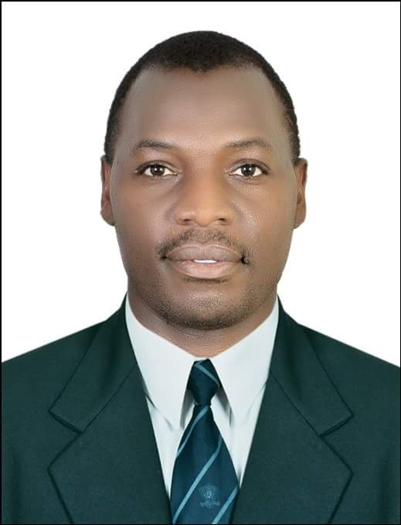 | IVAN  IVAN.370571@2freemail.com  barista  3 Years’ Experience

Personal Profile  personal profile  Core competencies  Work Experience  Education  Computer Skills | - Address: Abu Dhabi, UAE  - Nationality: Ugandan  - Date of Birth: 16/08/1988  - Employment visa  Service-focused barista with 3 years of experience delivering the highest level of customer service within a café setting.  Skilled at creating positive customer experience with friendly and efficient service, creating relationships with customers, greeting them by name and developing a consistent clientele  Effective communicator with excellent leadership and interpersonal skills with the ability to thrive in a multicultural environment.  - Excellent customer service skills  - Store Opening and Closing  - Relationship Management  - Transaction/Cash Processing  - Sales and Advertising  - Stocking and Displaying Merchandise  - Ability to multi task and work in a fast paced environment  - Ability to work independently as well as within a large team  - Ability to comply with work place conduct standards  - Microsoft office proficiency  Alphamed group L.L.C- Abu Dhabi, UAE  A COMPANY OF AL KHAYYAT INVESTMENT-AKI 2014 - May /2017 contract end  Responsibilities  - Greeting customers, provided information for specials and promotions, and setup advertisement displays for new incoming merchandise, beverages and bakery items  - Maintained a strong understanding of company values and customer needs, responding quickly to complex requests in a fast-paced environment.  - Made supply, food and beverage orders and prepared sales reports and payroll.  - Held coffee preparation demonstrations and assisted customers with selections of various coffee blends, teas, hot and cold espresso beverages, smoothies, and bakery items  - Performing safety inspections of the all office floor  - Support zero –incident safety culture and assume personal accountability and responsibility for safe work practices, activities and operations at the office  - Adhering to uniform and grooming policy as defined within company policy  THE SOUND CUP  Barista ( June 2012- October 2014)  Responsibilities  - Prepared amazing espresso-based specialty coffee drinks as well as brewed coffee beverages. Maintained clean employee and customer areas. Wide knowledge of gourmet coffees as well as techniques of grinding, roasting and brewing coffee.  - Sanitized equipment including steaming and brewing equipment, counters, glasses and dishes, and all fountain equipment.  - Enhanced customer experience with friendly service, professional Barista knowledge and outgoing demeanor. Excellent at remembering names and greeting customers with a smile.  - Took customer orders, maintained cash drawer, prepared sandwiches, desserts and other food items, stocked kitchen and store shelves. Tasked with overseeing food quality and training new employees, ensuring employees adhere to proper espresso brewing techniques  Achievements  - Enhanced the number of daily coffee, food and relevant beverage customers by 20% through extensive and effective customer service skills and ability  - Conceived and introduced the concept of customized coffee cup, where in the customer gets to choose all preferences stating from the choice of coffee bean to the cup  - Suggested a program of free gift cards with lunch meals which led to high volume of clients at a time of low customer traffic  The lawns fine dining and lounge bar  Waiter: ( 2010 to 2012)  Responsibilities:  - Welcome customers as they arrive and ask for seating preferences  - Seat customers and offer welcome drinks and menus  - Assist in menu setting and determining coffee, food and beverage of the week regularly  - Note coffee, food and relevant beverages orders and communicate to the kitchen  - Ensure orders delivery to the table in a timely manner  - Ensure quantity, quality and accuracy of orders  - Set up coffee, food and beverage stations and tables as directed  - Clean tables and ensure that they are bussed appropriately  - Mix and serve drinks as directed  Kampala paramedics Institute Uganda (2009 to 2010)  National certificate in medical laboratory technology  Caltec Academy makerere– Uganda (2005 to 2006)  Uganda advanced certificate of education -‘A’ Level  British system of education – British Curriculum  - Course combination majored in include physic, chemistry , biology passed with principle passes in all  Old Kampala senior secondary school (2001 to 2004)  Uganda certificate of education - ‘O’ level  - Passed with credits throughout the subjects covered which included, mathematics, physics, English, commerce, biology ,chemistry, geography, history, fine art  Sarah Institute of science and technology  Microsoft Office 2016 : (good in Excel, Word, and PowerPoint)  Languages: Excellent in spoken and written English language and currently learning Arabic.  Research: Qualitative and Quantitative Research skills  References, Certificates and Transcripts are available on request.

