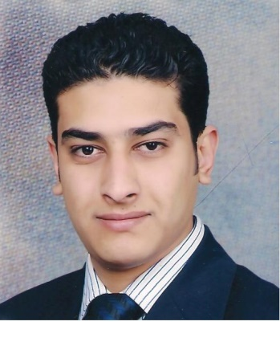
Ahmed Abd

E-Mails: ahmed.370581@2freemail.com

Education

2005-2009 Menofeya University Egypt

Faculty of Computers and Information, Information Technology Department

Current Work

From 9/2016 till now

Microsoft Technical Consultant at Raya Information Technology

Job Responsibilities is: -

Manage projects life cycle with the Systems Engineers

Design, Implement, Maintain and Support Windows Server Infrastructure

Design, Implement, Maintain and Support System Center Suite (SCCM, SCOM ...)

Implement, Maintain and support Enterprise Mobility Suite

Implement, Maintain and support Operations Management Suite

Implement Microsoft Azure solutions

About Raya Information Technology

Raya is a Microsoft Large Account Re-Seller (LAR), it’s main role is to sell, design and implement all Microsoft Products like: -

Windows Server with its services (Active Directory Services, DNS, DHCP ...)

System Center Suite (SCCM, SCOM, SCSM ...)

Exchange, Lync, SQL and SharePoint

Cloud Services (Azure, Office 365, EMS, OMS ...)

Samples of our customers

Banque Misr

Banque du Caire

Commercial International Bank (CIB)

Ahli United Bank (AUB)

Ahli International Bank (AIB)

The United Bank (TUB)

General Taxation Authority (G-Tax)

57357 Hospital

CICapital Holding

East Zeit Petroleum Company (ZEITCO)

Experience

From 9/2014 till 9/2016

Raya Information Technology as a Microsoft Systems Engineer

Job Responsibilities is

Design, Implement, Maintain and Support Windows Server Infrastructure

Design, Implement, Maintain and Support System Center Suite (SCCM, SCOM ...)

Implement, Maintain and support Enterprise Mobility Suite

Implement, Maintain and support Operations Management Suite

From 3/2014 to 9/2014

HSBC as a System Administrator: -

Job Responsibilities is

Administrate Microsoft systems like (Windows Server, SCCM ….)

Administrate and maintain desktop and web applications

Second level support for hardware issues

From 7/2011 to 3/2014

XceedCC Company (TE-Data Technical Support Account) as:

A Technical Support Engineer (7-2011 to 1-2013) My job responsibility is: -

Support End Users of ADSL service

A Technical Support & Soft Skills Trainer (1-2013 to 4-2014) My job responsibility is: -

Give the new comers training about ADSL technical support and soft skills

From 6/2011 to 1/2012

International Learning Institute as CCNA Instructor (Part Time)

From 6-2010 to 6-2011 (during military service)

Air Force Hospital as a System and Network Administrator:

My Job Responsibilities

System Administrator (Solaris 10 OS)

Cisco Networks (Implementation, Troubleshooting & Support)

Support End Users for Hardware and Software Problems

Training and Certificates

Microsoft

MCITP Windows Server 2008

Exam id 70-410: Installing and Configuring Windows Server 2012

Exam id 70-411: Administering Windows Server 2012

Exam id 70-412: Configuring Advanced Windows Server 2012 Services

Exam id 74-678: Designing and Providing Microsoft Volume Licensing Solutions to Large Organizations

Exam id 533: Implementing Microsoft Azure Infrastructure Solutions

Microsoft® Certified Solutions Associate

Certification Number: F132-5136

Certification/Version: Windows Server 2012

Microsoft® Certified Solutions Expert

Certification Number: F813-3386

Certification/Version: Cloud Platform and Infrastructure

Cisco

CCNA

CCNP Route

Unix

Unix Essentials Featuring the Solaris 10 Operating System

Intermediate System Administration for the Solaris 10 Operating System

Advanced System Administration for the Solaris 10 Operating Environment

Network Administration for the Solaris 10 Operating System

Graduation Project

Title: Database System

Description: Database system for the liver transplantation unit at National Liver Institute in Shebeen El-Kom

Tools: C# and SQL Server 2005

Grade: Excellent

Skills

Soft Skills: -

Hard worker and willing to learn new technologies.

Good Search abilities.

High communication skills.

Self-motivated.

Team player.

Work under pressure.

Ability to adaptation.

Co-operative.

Good tester.

Language Skills: -

Native language Arabic

Very good command of written, spoken and listen English

Interests

Football

Internet

Computer Games

English Movies

Personal Information

Date of Birth: June 2nd 1988.

Nationality: Egyptian

Marital Status: Married

Military service: Completed

