IBRAHIM
ELECTRICAL AND ELECTRONICS ENGINEERING
3 YEARS EXPERIENCE
Email: Ibrahim.370593@2freemail.com
PROFILE
I am a professionally qualified Electrical & Electronics Engineer eaving an experience of Three years. Now seeking to contribute my experience and skills to the management team at your company.
EXPERIENCE

Operator and Maintenance Engineer in Ghadeer Al Baida Water sweet LLC., RAK, UAE since 2015.
Operator and Maintenance Engineer
Able to manage RO Plant and maintenance
Manage all machineries related to bottling
Knowledge about quality control in water
Plant, with PLANT INCHARGE
Operator and Maintenance Engineer in Kerala State Electricity Board, Edarikode Substation during 2014-15.
Complete maintenance work of all Substation Equipment which include 110 / 11 KV, 12.5 MVA transformers, 110 KV current and potential transformers, 110 KV SF6 circuit barkers, 110 KV lightning arresters, 110 KV isolators, bus bars, 11 KV vacuum circuit breakers, all control and relay panels, fire fighting equipments, station battery, charger etc…
PERSONAL ATTRIBUTES
Highly organized, efficient, flexible and versatile team player, who will work hard and excel in any environment,. Being dedicated and committed, willing to take a challenging roles, tough assignments and capable to work under pressure and meet deadlines.

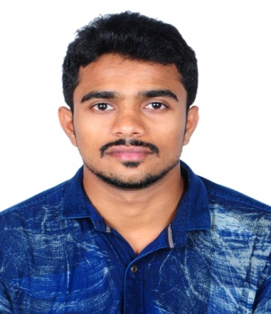
PERSONAL DETAILS

Date of birth : 21st Feb 1992
Age : 25
Nationality : Indian
Marital status : Single
Passport Details
Issue : 26/03/2012
Expire : 25/03/2022
Visa Status : Permanent Work Visa
TECHNICAL SKILL

AUTO CAD
MEP (Mechanical & electrical Plumbing )
Microsoft Office
ERP Tally
ACADEMIC PROJECT

Micro controller based automatic irrigation system
Automatic Counter.
IN PLANT TRAINING

Multi-disciplinary training centerKhadi and Village industries Commission
Kerala Electrical Allied Engg.Co LTD (KEL)

ACADEMIC QUALIFICATION

BE (Bachelor Of Engineering ) Electrical and Electronics Engineering
Anna University, Chennai, India (2010 – 2014
VHSC (Vocational higher secondary certificate )
Trade – Electrical
MRDA (Maintenance and Repairs of Domestic Appliances)

STRENGTH

Good analytical design and development skills
Self confidence, ability to grasp things quickly and flexible.
Confidence and consistent in producing result.
Capable to arrange the works according to the preference and importance.
Detail, efficient and goal oriented.
Able to tact workload and work pressure.
Excellent communication skills.
Ability to manage stress, time and people effectively.
Punctual, Innovative, Positive attitude and enthusiastic.

DECLARATION

I hereby declare that the above particulars furnished me
are true and correct to the best of my knowledge and
belief.

Place: RAK, UAE.

Industrial Functions

Steel industries Kerala Ltd, Kerala, India
Apollo tyros. Kerala, India
Electrical machine production center, Bangalore, India
HOBBIES

Reading Books,
Watching News
Listening Music.

LANGUAGE SKILLS

English
Hindi
Arabic
Tamil
Malayalam

IBRAHIM

