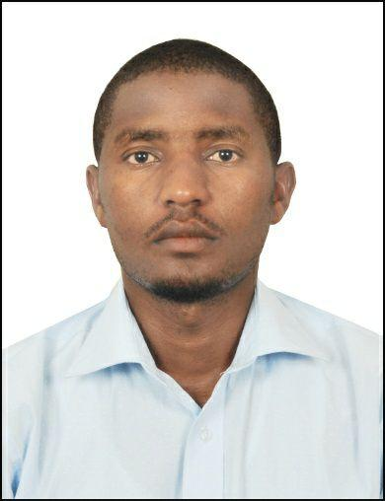
LWANGA

Email: lwanga.370598@2freemail.com

Career Objective
To enhance the development of professionalism and reach an expert level of skill

Core Competencies
- Client relations

- Strategic planning

- Market analysis

- Communication skills

Education Background
Bachelor's in Business Administration (Marketing) ​ |  | ​2007–2010
​2nd class upper
Makerere University |  | ​2005–2006
Uganda Advanced Certificate of Education​
Masaka Secondary School
 | Work Experience
Security Officer​,Spark security services |  | 2015- Present
- Ensuring safety of client's life, information and property

- Providing a link between administration, parents and service providers

- Proper administration of company premises
Marketing Salesman​,Mukwano Group of Companies(U) Ltd ​ ​2012–2015
- Helped in setting market targets and goals

- Planned and forecasted market trends

- Determined prices for company products

- Participated in designing/development of new products

- Analyzed market and solved customer complaints
Teaching Assistant​,Makerere University Business School ​ | ​2011–2012
- Prepared course outline

- Conducted lectures in faculty of management

- Marked coursework tests

Other Skills
Fluent in English, Responsible & reliable, Proficient in Microsoft word, excel, PowerPoint

