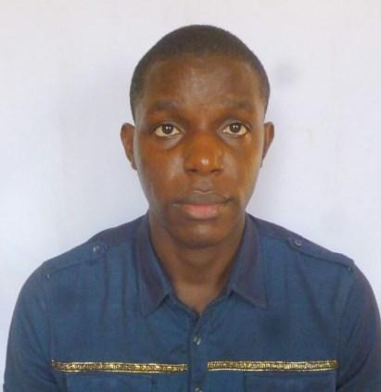
GABRIEL

Gabriel.370601@2freemail.com
Nationality: Nigerian

CAREER SUMMARY

- A skilled professional medical practitioner and locum doctor with 3+ years of experience serving patients by successfully diagnosing, treating, and managing illnesses and diseases.

- Experienced in the day to day management of a busy doctors schedule and practice

- Proficient in maintaining the daily report of patients and medical file records

OBJECTIVES

- To be able to put into practice my gained knowledge and experience in a dynamic clinical facility in healthcare industry.

- To show diligent, hard work, team spiritedness and initiatives in the management of patients and fulfilling hospital’s mission.

WORK EXPERIENCE

Facility: | Salamatu Clinic and Maternity Hospital, Kano State Province, Nigeria
Date: | December 2014 | - | February 2017
Post held: | Medical officer
Responsibilities:
 | ▪ History taking and clinical examination in both emergency and nominal
 | scenarios;
 | ▪ Responsible | for | accident and emergency (A&E) medical treatment,
 | general outpatient as well as in- patient care;
 | ▪ Performed procedures such as circumcision, manual vacuum aspiration,
 | instrumental and non- instrumental labor deliveries;
 | ▪ Assisted several surgical procedures such Caeserian Section,
 | Myomectomy, |  | Appendicectomy, | Exploratory | Laparotomy,
 | Thyroidectomy, Herniography, etc;

▪ Coordinated immunization activities following the National Program of Immunization;

▪ Keeping up to date with the latest treatments, medicines and medical developments for a robust health care of patients

1

Facility: Murtala Mohammed Specialists Hospital, Kano State Province, Nigeria

Date: November 26, 2013 – November 26, 2014

Post held: House Officer

Responsibilities:
▪ 12 months internship rotation; Internal medicine (3 months), Obstetrics
and Gynaecology (3months), Pediatrics(3months), Surgery(3months);
▪ Main task as an intern was to recognize problems in high risk patients
▪ Ordering necessary investigations and instituting appropriate primary
treatment plan
▪ Carried out general medical procedures such as setting of intravenous

lines, urethral and suprapubic catheterization, etc;
▪ Developed an overall idea of the methods of data maintenance in all the
different departments

EDUCATION

November 2006 – Bachelor of Medicine and Bachelor of Surgery (MBChB), September2013 College of Health Sciences,

Obafemi Awolowo University, Ile Ife, Nigeria.

PROFESSIONAL BODIES

Registered Member, Nigeria Medical and Dental Council of Nigeria

Registered Member, Nigeria Medical Association

PERSONAL QUALITIES
- Excellent writing and verbal communication skills;

- Team building skills with ability to lead, motivate and collaborate with colleagues;

- Ability to organize and priotize work load during busy periods, and manage multiple case files concurrently;

- Good outreach qualities and patient liaison on feedback on the quality of service of practice

References: Available on Request

2

