CURRICULUM VITAE

Suhail.370602@2freemail.com

NAME :- SUHAIL
NATIONALITY :- INDIAN
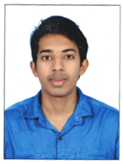

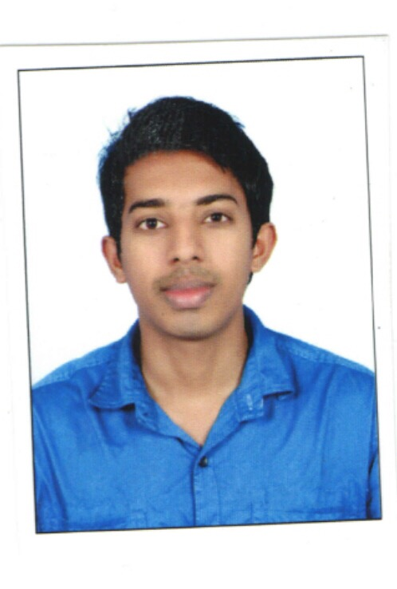

CAREER OBJECTIVE

To prove my competence in the field of Pharmacy by using my abilities and to acquire a position where I can work towards the fulfillment of organization goals.
JOB FUNCTIONS
- Provide prescribed medications, drugs, and other pharmaceuticals as needed for adequate patient care.
- Dealing and dispensing with all the insurances.

- Assemble a great team and schedule their work so the pharmacy is always functioning at peak performance.

- Supervise the fulfillment of prescriptions by pharmacy technicians.

- Communicate policy and procedure changes, system enhancements and clinical updates to all pharmacy staff.

- Ensured that every customer received friendly, knowledgeable, and efficient service.

- Checked all work done by pharmacy technicians prior to dispensing medications.

- Ensure continual compliance with all state and federal rules and regulations.

ACADEMIC ACHEIVEMENTS AND CERTIFICATIONS

- DHA ( DUBAI HEALTH AUTHORITY ), UAE ELIGIBLE

- Bachelor of Pharmacy from Srinivas College of Pharmacy, Under Rajiv Gandhi University of Health Sciences, Karnataka August 2013 with an aggregate of first class.
- Higher secondary from Board of HSE Kerala, March 2009 with an aggregate of first class.
- SSLC from Board of Public Examinations Kerala, March 2007 with an aggregate of first class with distinction.

PROFESSIONAL EXPERIENCE:
- Pharmacist Executive,

Life pharmacy Sharjah, 2 years of experience. From June 2015 to May 2017

- Registered Pharmacist,

Gopinathan Orthopedic center, Nadakkavu Calicut. From November 2013 to April 2015.

COMPUTER SKILLS

- Competent user of MS office (MS-Word, Excel, Power point, etc.) Adobe PageMaker, Photoshop, etc.
- Proficient in use of internet, e-mail and work related databases.
- Experience in pharma softwares

PERSONAL PROFILE

Sex : Male

Marital Status : Single

Religion : Islam

Nationality : INDIAN

Languages known : English, Hindi, Malayalam, Tamil, Arabic

Current Location : Sharjah

REFERENCE:

DECLARATION

I hereby declare that the above information and particulars are true and correct to the best of my knowledge.

SHARJAH

