Curriculum Vitae

Shamshur

shamshur@2freemail.com

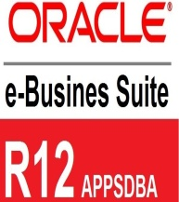

Work Summary:
- Over 8 years of experience in Facilities Management Administration, Software Enterprise Asset Management (EAM / CAFM), Construction Database management, Administration, Technical Content Writing, Client Relationship, and Team Management.
- Excellent professional communication skills,
- Superior attention to detail, calm under pressure, proactive and confident.
- Standing ability to develop and maintain constructive and cooperative working relationships with individuals at all levels of the organization.
- Management, data development, Issues resolution, Training and Development.
- Computer literate and internet savvy.

FUNCTIONAL EXPERIENCE
Functional Experience | Specialist Area | Years of Experience
Construction/Facilities Management | MEP/Civil Asset Data Base Management, Commercial & Residential | 4 Years
BPO/KPO/Software | Operations/CRM/Oracle, SQL Management Studio EAM/CAFM support ,SAP, Technical Writing | 4 years

Work Experience:
Tafawuq Facilities Management

- Working on interface of SAP R/3 Plant Maintenance module application for diversified project.
- Maintaining Master data for the Assets, Function Location, Equipments.
- Upload the Master Data in SAP R/3.
- Upload Maintenance Planner in SAP.
- Maintaining SAP Financial as per the Plant Maintenance PM module and Profit center & Cost center
- Processing Asset tagging in CAFM
- Trouble shoot SAP data base query and application issue.
- Trend analysis of MEP-Civil Jobs.
- Asset Management Data base report.

Inaya Facilities Management
Worked as a CAFM/EAM Administrative Officer/Team Leader in Inaya Facilities Management ,Dubai w.e.f 10 August 2011 to Oct 2015
- Leading a team of EAM/CAFM associates & Facilities Management call center associates for a MEP/Civil residential & commercial project-Malls
- Administrating the premium commercial and residential properties.
- Working on interface of EAM and CAFM application for diversified project creating work requests and work orders.
- Customizing Oracle EBS R12 EAM and CAFM interface
- Processing Asset tagging in CAFM
- Troubleshoot EAM/CAFM application
- Assigning PPM (Plan Preventive Management) work to the technical MEP-Civil team
- Asset Management report and CRM report
- Training Delivery and Management Instructional Design
- Generating QMS process documents
- Drafting newsletter, quotation, and business proposal
- Maintaining Customer service report& monthly dashboard
Interacting with the clients and customers
- Handled the content development process for training modules.
- Managed the process linked with client interface, designing of updates and modules as per the standards set by the client.
- Developed online repository of product knowledge and updates.
- Maintain current product knowledge for each CRM member by taking calls, attending team meeting
- Conducted Dipsticks and monthly assessments to assess the floor health
- Quality analysis for the team
- Updating the Weekly and Monthly reports to Client
- Check listing the data, which are fed into the System

Ayush Software Pvt Ltd

Worked as a Content Technical Writer in Ayush Software Pvt Ltd w.e.f May 2010 till May 2011

- Content development for effective optimization
- Doing research analysis for the key words
- Technical writing for Safex touch screen, Samsung Corby and Nokia.
- Developing Instruction manual for training
- Social media management
- E-Marketing management
- Uploading pictures and contents
- Writing application and product manual
- Scripting review of the Electronic gadgets
- Checking plagiarism of the contents uploaded on the websites
- Updating the old contents on the web-site
- Take care of the work allocation received from the offshore clients on the daily basis.
- Updating client record in the system

World Network System
Aviva UK

Worked as Senior CSA - (AVIVA U.K) in WNS Global Services w.e.f 26 Nov 2007 till 10 May 2010

- Administrating and coordinating with the AVIVA UK Clients and the customers
- Processing live policies and underwriting terms on SAP database
- Developing Customers Insurance Underwriting documents for the insurance product and updating new updates and newsletters
- Writing proposal for the customer as per the request received
- Designing instruction manual for the training, conference and meeting purpose
- Sending letters and manual invoice to the policy holders
- Updating the Weekly and Monthly reports to Client
- Check listing the data, which are fed into the System
- Maintaining all official record related AVIVA Healthcare Insurance
- Provide process training

Educational Qualification:
- Bachelors of Arts - Passed in 2009 from Bharti Vidyapeeth University
- Masters in Computer Application-Passed in 2011 from IIMe.
- Diploma in Construction Management-Passed in 2012 from IIMe.

Professional Diploma:

1-Completed Advance Diploma in Technical Writing Certification from System Domain in 2009

Skills:
- Software technical writing
- Bid writing
- Documents Designing
- Fliers, Brochures and Newsletters
- QMS Instructions and User manuals

Computer tools: Content Management System(CMS), thebox.net, Instructional designing, Robohelp, Snag-IT, visio, Microsoft Word, Excel, Power Point, HTML

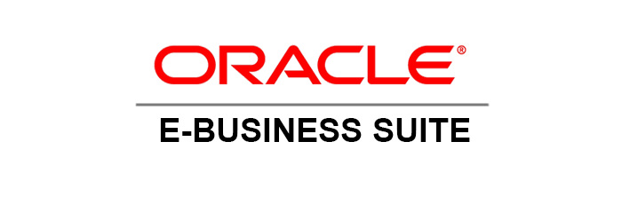
2-Completed Certification of Oracle EBSR12 in 2015 from Radical Technologies
- Customizing Oracle EBS R12 EAM and CAFM interface
- Integrate and manage the Data Base
- Customization of Oracle Form

