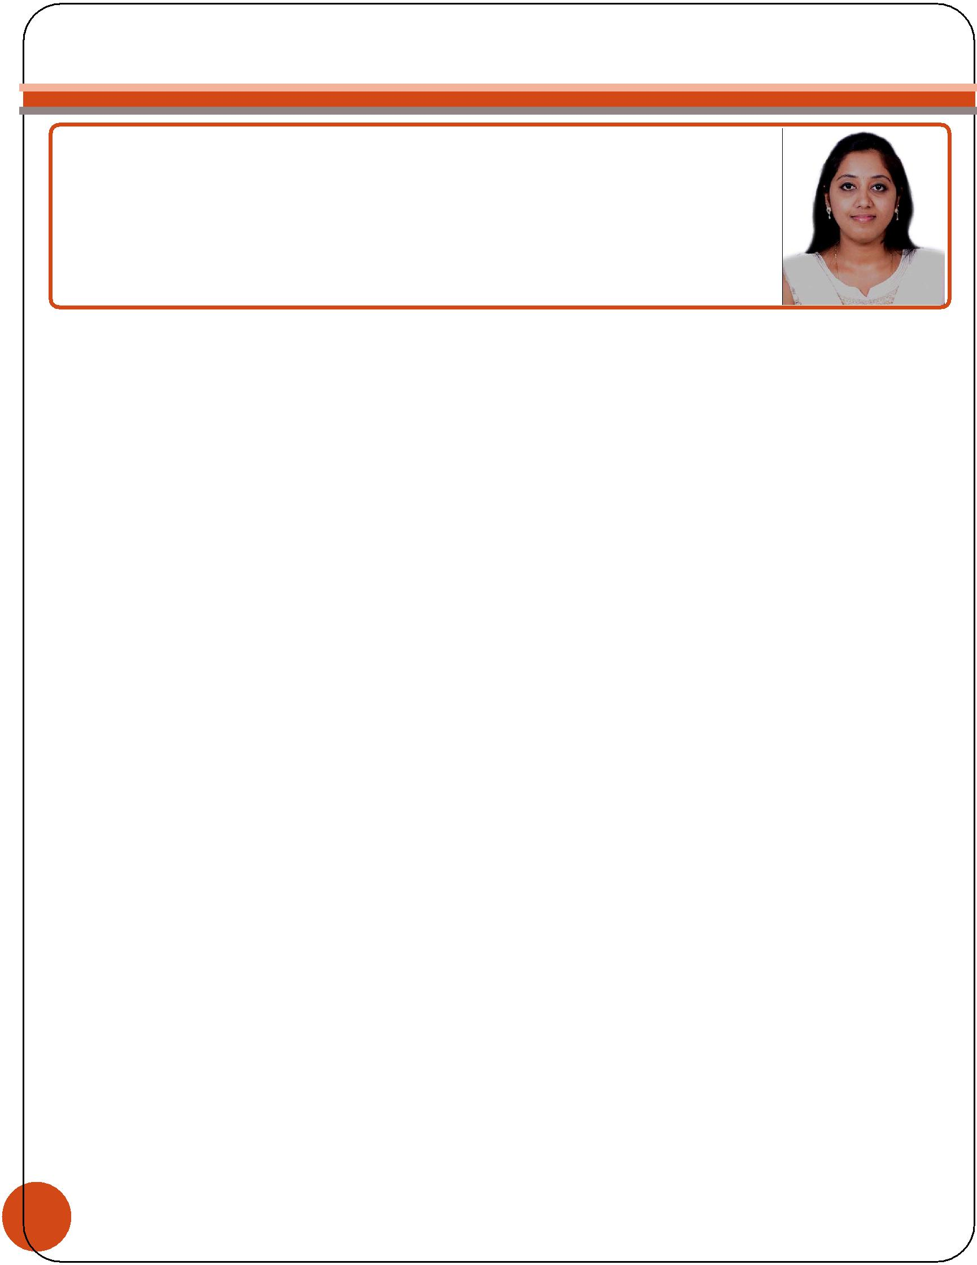
Curriculum Vitae

Thejashree

Thejashree.370611@2freemail.com

Career Objective

Looking for the suitable position in a highly reputed organization where my knowledge and experience can be utilized to the maximum.

Academic Qualifications and Certifications :

Degree | : | Bachelor’s Degree Of Electrical & Electronics Engineering
Year of Passing | : | 2011
University | : SBMJCE (Sri Bhagawan Mahaveer Jain College Of Engineering) (VTU)

Technical and Professional Skills :

- Admired Experience working as an Quantity Surveyor with 3.8 years of confirmed capability in Project Management.

- Experienced in electrical designing for diversified projects including renovation and remodeling projects for various construction projects.

- Proficient in MS-Office, PRIMUS, AutoCAD, Solid Edge.

- Sound knowledge of the techniques of preparing estimation.

- Ability to provide effective solutions for any technical issues with new and existing designs.

- Ability to interact effectively with clients and associates and create excellent rapport.

- Hard working, loyal and confident worker with a go getter attitude.

- Passionate to deliver my best for every project.

Career Experience:

Langdon & Seah Consulting India Pvt. Ltd. (An ARCADIS Company), Bangalore

Designation : Quantity Surveyor – MEP

Duration : Jan-2015 to Oct-2015

1

Projects Handled :

¨ Juniper Networks-Elnath(Phase-1) & JTAC Ultra Lab @ Bangalore ( Commercial Project )

Clients | Juniper Networks India Pvt. Ltd.

Architect | Symmetrics Development Services Pvt. Ltd

Scope of Work | Interior Fit-outs

Scope Of development | 0.63 Million Sq. ft. for Area Approximately

Project Value | 36.9 Million USD

¨ JP Morgan Chase @ Bangalore ( Commercial Project )

Clients | JP Morgan Chase

Architect | Space Matrix Design Consultants Pvt. Ltd.

Scope of Work | Interior Fit-out Works

Scope Of development | 0.21 Million Sq.ft. for Area Approximately

Project Value | 9.5 Million USD

¨ Maker Retail Mall @ BKC (Bandra Kurla Complex), Mumbai ( Retail Project )

Clients | The Indian Film Combine Pvt. Ltd.

Architect | ARCHGROUP International Architects Pvt. Ltd

Scope of Work | Shell & Core, Interior fit-out Works

Scope Of development | 1.31 Million Sq.ft. for Area Approximately

Project Value | 80.45 Million USD

Roles & Responsibilities in

Pre-Contract:

- Preparation of Cost Plan & Budget.

- Liaising with Vendors.

- Preparation of Pre-Qualification Evaluation reports of Vendors.

- Preparation of Bill of Quantity & Tender documents.

- Preparation of Measurement take off & Pre-Tender Estimation.

2

- Preparation of Tender Evaluation, Tender Questionnaire & Recommendation reports.

- Preparation of Contract Documents.

Kanakadhara Ventures Private Limited. RajajiNagar , Bangalore

Designation : Asst. Engineer – QS (MEP-Services) Duration : Feb 2012 – Dec 2014

Projects Handled :

¨ ESIC Medical College & Staff Housing ( Commercial & Residential Project )

Clients | ESIC Government Project

Architect | Design Associates.

Scope of Work | Turn-key Project

Scope Of development | 14.60 Lacks Sq.ft. for Area Approximately

Project Value | 305 Crores

Responsibilities:

¨ Preparation of sub – contractor bills and client bills.

¨ Reading each & every line in BOQ specification to aware the claim in each & every items.

¨ Calculating measurements for procuring the material in each & every activity according to the BOQ specifications.

- Prepared detailed records of the estimate provided a break-up, which included the material cost & the materials required for the project.

- Compiled the cost of the subcontractors & all the indirect cost that occurred in the project.

- Comparing the structural drawings & architectural drawings to aware the changes in the drawing.

- Reading & interpreting drawing/BOQ.

- Preparing rate of analysis for extra item..

- Analyzing on the basis of actual work done for every month.

- Highlighting the extra items to the management to apply extension of time & indirect cost.

Job functions :

¨ Coordinated with the engineering and construction team to derive site requirements.

3

- Verified the project milestone & other specification provided.

- Provided material specifications for wiring and other installations.

- Handled & Prepared a list of all indirect costs that were incurred in the project such as the manpower, temporary facilities & the other running expenses.

- Renovated existing designs and implemented the latest features to ensure safety.

- Maintained detailed documentation for all projects.

Computer Applications
¨ Post Graduated | : | Diploma In Computer Application.
¨ Operating System | : | Windows 95/98/2000/NT/XP.
¨ Application package | : | MS Office , PRIMUS, AUTOCAD.
Personal Details
➢ Husband Name | : | Chandra Shekar P
➢ Marital Status | : | Married
➢ Nationality | : | Indian
➢ Gender | : | Female
➢ Languages known | : | English, Kannada, Hindi & Marathi

➢ Hobbies : | Reading books, Music, Badminton, Learning new languages, Morning Walk
& Volunteer service to Sai Super - Specialty Hospital.

Declaration

I Hereby, declare that the above written particulars are true to the best of my knowledge and belief.

Date | : | Yours Faithfully,
Place | : Dubai | ()

4

