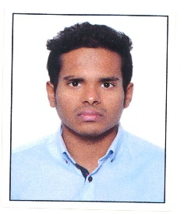
JOBIN
Email id: jobin.370625@2freemail.com

Objective:
Seeking a position in an organisation which deals multi industry where my broaden spectrum of interests, diverse educational and background can significantly impact organization’s growth and my personal growth.

Core competencies
- Commercial awareness
- Collaborative team‐player demonstrated through my involvement in various non‐profit organisations
- Language proficiency in English, Hindi and Malayalam, limited working proficiency in Arabic
- Adaptive to all working environment
- Negotiation and persuasion
ACHEIVEMENT:
- Participated in guest lecture series on Partnership firm organized by department of Accountancy
- Participated on workshop on Accounting standards
- Attended seminar on stock market and derivatives
- Attended National seminar on inclusive growth in India-varied dimensions and challenges

EXTRA CURRICULUR ACTIVITIES:
- Assisted in organizing National seminar on Inclusive growth in India
- Participated in voluntary blood donation camp
- Participated in Pune tree fest organized by Aura foundation
- Took active roles in school functions and sports events
- Participated in college cultural events
- Participated in SYMAGINE( college fest)
LEADERSHIP:
- Responsible member of College Discipline committee
- Core member in organizing college fest
QUALIFICATIONS:
Bachelors of commerce from Symbiosis college of arts and commerce, Pune - 2016
Pre-university education in Gulf model school, Dubai
Currently pursuing Msc logistics from University of Wollongong, Dubai 2017- 2019
Certification:
Completed certification of investment banking operations(CIBOP) from Imarticus learning, Mumbai

HOBBIES AND INTERESTS:
- Fitness Enthusiast
- Travelling
- Reading

