Ibrahim

Architect
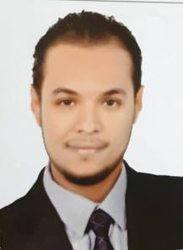

I am seeking a career in the field of Architecture. I understand that success in

any task requires responsibility, inspiration and cooperation and I work hard to achieve this. In our field nowadays a lot of attention on Safety,

Accuracy, Efficiency, Honesty, Completeness, and Creativity

CONTACT ME

PROFESSIONAL SKILLS

Acad

3D Max

Photoshop

MS Word

MS PowerPoint
MS Excel

Qualifications/Certifications

- AutoCAD from Mansoura University.

- 3D MAX from Mansoura University.

- Photoshop from EGC

- Presentation skills BY Ahmed Ashore.

- HR & teamwork skills BY Ahmed Ashore .

- Communication skills BY Ahmed Ashore.

- Managing time skills BY Ahmed Ashore.

- Managing and Avoiding stress during

work skills BY Ahmed Ashore.

LANGUAGES

Arabic

English

Ibrahim.370633@2freemail.com

WORK EXPERIENCE

I have experience in Dubai

01/2016 Consultant Engineer
- At Mina marco engineering consultants office

03/2017
- Engineering Authority of the Egyptian ARMED FORCES Badr ,Egypt (1047) residential buildings project at Rubiky road ,Badr city

I was responsible for detailed supervision and inspection to ensure that the project is constructed according to the plans and specifications with the help of (14) consultant engineers under my supervision from (06/2016) to (03/2017).

• | I supervised the construction of administrative and | Ismailia ,Egypt
 | commercial tower project composed of (11) floors at the
 | government of Ismailia from (01/2016) to (05/2016).

08/2013 Site Engineer

; Cairo ,Egypt
At El-Sayed Zaater Co. For Engineering & contracts
12/2016

- I supervised the engineering work carried out by At El-Sayed Zaater Co. in Implementation of a projects for AIR DEFENSE in the ARMED FORCES represented in :-
- Construction of concrete hanger (20m*50m) with highet (6/7m).

- Construction of concrete wall with length (992m) and height (6m).

- Raise the efficiency of the command center (major general 95 warning).
- Construction of the command center (battalion 44 radar).

- Construction of (2) observation tower.

- I have experience in estimation.

EDUCATION

Bachelor degree in Architecture

 | From Delta Higher institute of engineering and technology |  | Mansoura
 | Estimate
2008 - 2013 |  | Good
 | Graduation Project | Replacement and Development | of slums Gedela
 | area (Mansoura city)
 | Project Estimate | V good

Military service Unrequired

PERSONAL SKILLS
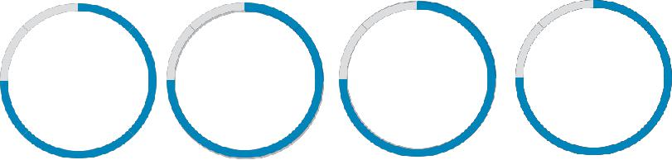

Team | Creativity | Organization | Leadership
Work

