CV

Ali

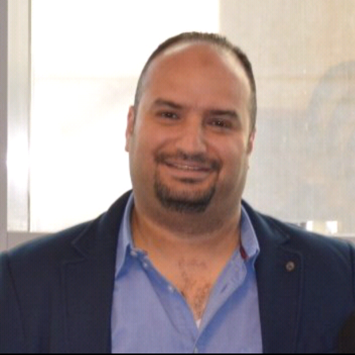

Discipline

Management

Position
MABconsult Projects Manager (DE, PM)

Architect.
Email: ali.370642@2freemail.com

Objective
Having more than thirteen (13) years of proven experience with leading Project Management &Consulting Engineering and Contracting Companies in the Kingdom of Saudi Arabia, Kingdom of Bahrain, seeking new challenges in Design and Construction management companies which effectively utilizes my professional experience.
Capability summary
An experienced projects manager with a broad base of technical, management and leadership skills with the capability of delivering projects on time and within budget. Worked on projects in the Middle East in nearly all facets of the construction industry.
Over Thirteen (13) years of solid experience in project/program management including construction management, cost and schedule control, contract management, HSE and QA/QC management and contract administration.
Projects included: Commercial Buildings, Residential Buildings, Hotels, Retail Centers, Parking Structures, Industrial Facilities, and Infrastructure project
Presentations to Clients/Authorities/Stakeholders, including preparation Reports and Agenda.
Ability to handle Middle and Large Scale Projects
Management of Overall Project Schedule, Milestones, and Budget
Quality control at the maximum efficiency and minimum cost
At present attached to MAB Consult located in AL Khobar, Saudi Arabia (KSA) as Deputy office manager (Projects Manager and Design manager) have been assign to lead the design team and to set the design process .
Monitoring the Project managers and to insure that our projects on the right truck
Qualifications

B.Sc. Architecture Engineer, Egypt (2004)

Memberships

EES, SE, Discreet

Regional experience

Middle East over Thirteen years | with transferable Iqama

01

CV

Ali

Key technical competencies:

- Client Engagement / Negotiation Skills

- Cost Verification

- Change Control

- Cost Management

- Risk & Opportunity Management

Highlighted sector experience:

- Retail

- Commercial

- Leisure & Hospitality

- Residential

- industrial

- Cultural

Systems and tools capability

- AutoCAD / 3d Max / Photoshop

- Primavera / MS Project (basic)

- SAP For Hana

- Free Hand

Work Experience

Projects Management (MABconsult | Shade co |RTCC\RSR)

Leading a team of Engineers of all disciplines Civil, Mechanical and Electrical
For the entire Project & Construction Management,
Site Supervision and Contract Administration
Responsible for costing, estimating and planning projects.
Preparing Project Initiation documentation.
Responsible for ensuring best value is obtained for the project
Including supplier base, use of internal and external resources.
Maintaining and completing Project Key Performance Indicators.
Writing detailed and summarized project progress reports.
Identifying, costing and processing any contract variations.
Tracking activities against the detailed project plans.
Updating project plans to include agreed changes.
Producing accurate financial reports.

Residential
Al Remal Compound, KSA

Including: 134 UNITS OF VILLAS, DUPLEXES, TOWNHOUSES, STUDIOS
APARTMENTS AND REC CENTER |TOTAL AREA: 22000 m2
Budgets: 180,000,000 SR
Position : Projects manager MABconsult | June 2016– still

02

CV

Ali

ARAMCO Labor camp –Hawiyah, KSA

Including: Residential Park on area of 1,000,000 Sq. for 12,500 worker
(Seniors, juniors and laborers) Accommodation, creational facilities and
Utilities| Industrial Park on area of 1,500,000 Sq.
Budgets: 300,000,000 SR
Position : Sr.Project manager- MABconsult | August 2013–October 2014
| Design& PM
Royal Commission Labor camp 01–Ras Al Khair, KSA

Including: Residential Park on area of 200,000 Sq. for 2,500 worker
(Seniors, juniors and laborers) Accommodation, Recreational facilities
And utilities| Budgets: 95,000,000 SR
Position : Sr.Project manager-MABconsult |April 2014–February 2016
| Design& PM
Royal Commission Labor camp 02 –Ras Al Khair, KSA

Including: Residential Park on area of 75,000 S Accommodation,
Recreational facilities and utilities| Budgets: 130,000,000 SR
Position : Sr.Project manager-MABconsult | March 2014–Nov2015
| Design& PM
AL Tamimi Palace, Al Khobar

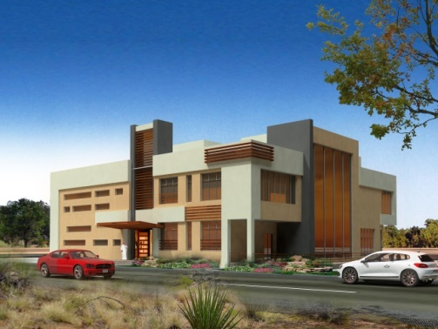
Including: Basement/G.Floor/1St Floor (High end Project) from a
Different culture | TOTAL AREA: 7500 m2 | Budgets: 39,000,000 SR
Position : Sr.Project Manager-MABconsult |16 June 2013–30 June 2014
| Design& PM
Commercial

Managed the project team including any subcontractors.
Ensuring Projects and Programs are executed using agreed standards
& processes.
Reviewed and approved all project documentation.
Resolved any problems and issues that arose.
Undertook all monthly project financial cost reporting.
Preparing status reports for use in communication to stakeholders.
Ensured staff and sub-contractors timesheets were accurately completed
Provided project support for all-off site activities.

ADEER Tower, KSA

Including: 22 Floors of an Office building, Mezzanine, 3 basement as a car
Parking, Penthouse and High end restaurant | TOTAL AREA: 32,000 m2
Budgets: 125,000,000 SR
Position : Project manager-ASDO Consult | October 2012- June 2014

AL RASHID TOWER, KSA, Riyadh | Design& PM

Including : Providing corporate exclusivity at the highest level, the Office
Tower, 12 stores of dynamic, 3 basements used as a Car parking and a
Mezzanine floor | TOTAL AEREA: 21,000 m2 | Budgets: 165,000,000 SR
Position : Project Manager-RTCC\RSR | JAN 2007 – April 2009

CV

Ali

Retail

AL RASHID MALL EXPANSION, KSA| Design& PM
Including:
Mall Extension Building: 64000 m2| Car parking Building for
2000 cars: 72000 m2| Hyper Market Building: 170000 m2
Mall bridge building: 21000 m2| HVAC plant: 10000 m2
Mosque: 12000 m2| Budgets: 650,000,000 SR
Position : Construction Manager-RTCC\RSR | AUG 2005 –JAN 2007
Patties France restaurant, KSA

Including: High-end restaurant | TOTAL AREA: 3000 m2| Design& PM
Budgets: 12,000,000 SR
Position : Sr.Project manager-MABconsult | May 2014– April 2015
AHAB restaurant (Vanilles, Popyes & Caliburger), KSA

Including: Fast food restaurant | TOTAL: 11 NO | Design& PM
Budgets: 12,000,000 SR
Position : Sr.Project manager-MABconsult | JAN 2015– March 2016
Parker & Salt restaurant, KSA

Including: High-end restaurant | TOTAL AREA: 2400 m2
Budgets: 4,000,000 SR
Position : Sr.Project manager-MABconsult | Oct 2015– Aug 2016

Government, Infrastructure

KING FAHAD CAUSWAY, KSA & Bahrain

Shade Contracting Company LTD

Including: A - Modification Of cargo Arrival / departure area Bahrain | April 2009- March 2010.
B - Construction & Renovation. Of Custom and Immigration offices in Bahrain | March 2010 –Oct 2012.
C - Construction & Renovation .Of Custom and Immigration offices in SAUDI | OCT 2009 - SEPT 2011.
D - Construction of public services buildings in SAUDI ARABIA and Bahrain | SEPT 2010- 1 MARCH 2012.
E - Construction of VIP Reception in SAUDI ARABIA | APRIL 2012 –
OCT 2012

Infra structural work (electrical-water supply-drainage-fiber optic cable-Pipe protection and manholes /asphalt/side protection/lighting pole/space Frame shade/ Concrete work/Boundary precast wall/new precast Cabinet / renovation of the Existing building/curve stone/finishing work/Pre-Engineering building /Siporex slab/metal decking slab/block work inside and outside/windows /Marble tiles /renovation of old buildings/cladding
Budgets: 65,000,000 SR
Position : Project manager-Shade co ltd | April 2009– OCT 2012

CV

Ali

Industry and manufacturing
Golden chicken, KSA

Including: Factory with Office building attached | TOTAL AREA: 7500 m2
Budgets: 42,000,000 SR
Position : Project manager-RTCC | Feb2007– Aug 2008
GTE Office &Showroom, KSA, Al Khobar

Including: 3 Floors office, Showroom, Workshop | TOTAL AREA: 9000 m2
Budgets: 22,000,000 SR
Position : Sr.Project manager-MABconsult | Aug 2016- Present

Other

Al Taqwa Mosque, KSA

Including: Grand mosque | TOTAL AREA: 2500 m2
Budgets: 12,000,000 SR
Position : Sr.Project manager-MABconsult | July 2013- Aug 2014
| Design& PM

Barrari Resort, KSA, Al Khobar (Renovation | Design& PM)

Including: 30 Executive villa, Wadding Hall, Coffee shops, Recreation area, Reception and Admin BUILDING | TOTAL AREA: 17000 m2
Budgets: 15,000,000 SR
Position : Sr.Project manager-MABconsult | April 2014- Oct 2016

Design

Al Rashid MALL, KSA, ALMADINAH

Including:- Mall Building: 64000 m2| Hyper Market Building: 120000 m2
Budgets: 260,000,000 SR
Position : Lead Architect –RSR\RTCC| Nov2004– Jan 2005

Al Rashid MALL, KSA, AL Khobar

Position : Lead Architect- RSR\RTCC | Nov2004– Aug 2005
AL RASHID TOWER, KSA, Riyadh

Including : Providing corporate exclusivity at the highest level, the Office
Tower, 12 stores of dynamic, 3 basements used as a Car parking and a
Mezzanine floor | TOTAL AEREA: 21,000 m2 | Budgets: 165,000,000 SR
Position : Design Manager-RSR\RTCC | AUG 2006 – JAN 2007
Unizah resort by Sheraton 4 points, KSA, Unizah

Including : Main hotel, 30 villa, 20 Chalet, Multipurpose hall, Spa
| TOTAL AEREA: 28,000 m2 | Budgets: 180,000,000 SR
Position : Design Manager-RSR\RTCC | JAN 2017 – Still

05

PERSONAL Information:-

Date of birth : Nov 21, 1981
.
Place of birth : Ismailia, Egypt.

Nationality : Egyptian.

Marital status : Married with two kids

Military status: Exempted.

Training:-

Training in El Beeah (planners, Architects & Engineers) in Riyadh-Kingdom of Saudi Arabia from (2000 – 2001).

Training in Al Rashid Trading & Contracting Co. (Corporate Headquarter-Contracting Sector) in Riyadh-Kingdom of Saudi Arabia from (2001–2002).

Training in Talaat Mustafa – Tattwer in (El Rehab City) Cairo-Egypt
From (2002 – 2003).

Training in Al Estesharyoon ZUHAIR FAYEZ Partnership Architecture, Engineering (Cairo office) Egypt from (2003 – 2004).

Trainer the computer courses (AutoCAD 2002-adobe Photoshop) for
Students of architecture engineer's department at (HIGHER TECHNOLOGICAL INSTITUTE).

06

Selected experience Middle East

RTCC / RSR

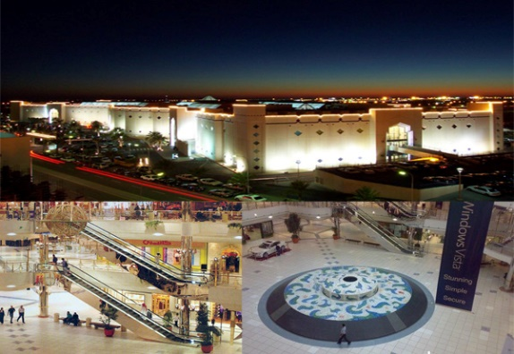

Client
Al Rashid Trading and Trading Company
Project
Al Rashid Mall, KSA, Al Khobar

SHADE CO LTD

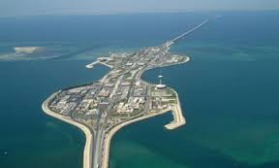

Client
King Fahad Causeway Authority
Project
KFCA, KSA, Bahrain

RTCC / RSR

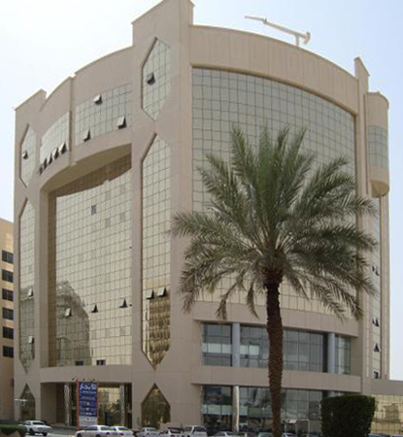

Client
Al Rashid Trading and Trading Company
Project

Al Rashid Tower, KSA, Al Riyadh

ASDO

Client
SAMU
Project
ADEER Tower, KSA, Al Khobar

07

Selected experience Middle East

MABconsult

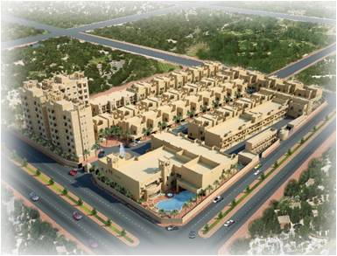

Client
ABDULRAHMAN AL BASSAM GROUP
Project
Al Remal Compound, KSA, Al Khobar

MABconsult
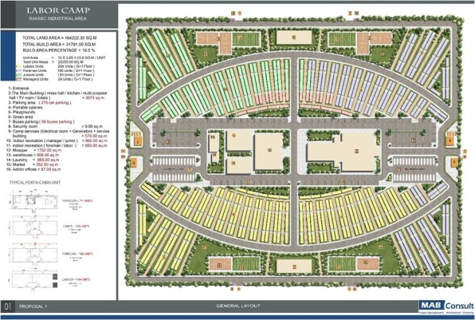

Client
Royal Commission, TAFGA
Project
Residential Camp 1, KSA, Ras Al Khair

MABconsult

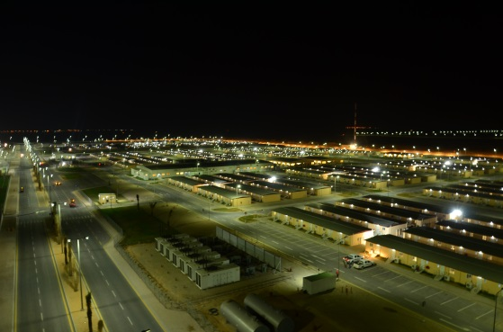

Client
Saudi Aramco
Project

TAFGA, KSA, Hawuiyah
MABconsult
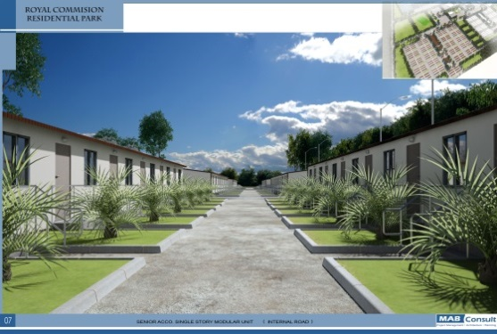

Client
Royal Commission, TAFGA
Project
Residential Camp 2, KSA, Ras Al Khair

08

