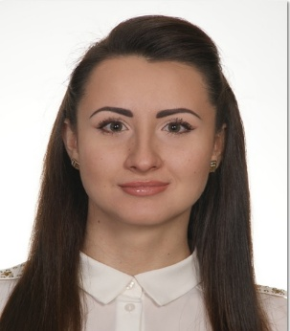 | Mariia  Mariia.370656@2freemail.com  Dubai, United Arab Emirates
Objective  Education:  University:  Faculty:  Specialization:  Graduation year:  Work experience:  Computer skills:  LANGUAGES  Interests:  PERSONAL INFORMATION:  Other skills: |  | To seek position requiring energetic nature, where business expertise, self motivated and team work committed to support company objective .  Chernigiv State Institute of Economics and Management  Management  Management of tourism industry  2012  From May 23,2016 till June 11, 2017  HBMM (Hart Bernstein Marketing Management) as Sales and Marketing executive.  Job description:  checking and reviewing branding contracts to promote brand name, products and services.  provides complete information about the brand and demonstrates how a product works.  Interacts with customers and sales prospects and provides customers feedbacks regarding the brand to sale.  Performs other sales and marketing duties relevant to promoting the brand.  Coordination with sales department for legal documentation \ terms and conditions related queries all over Dubai.  Ensure all brand marketing activities and amendments are done accurately as per instruction received from the customer and as per countries legal contractual requirement.  Adhering to the terms and conditions in promoting brands and also considering various compliances.  Custodian of all legal contracts \ applications , letters and amendments.  Analyzing all documentation for reporting and review to higher management.  Monthly review meeting with sales department and branches all over Dubai.  From Sep 26, 2014 till Mar 1, 2015, Events organizer in Avari Hotel and Middle East Group hotels.  From Feb 28, 2013 till July 10, 2013, Hostess in Abjar grand hotel L.L.C .  From Jan 15, 2012 till Dec 14, 2012 , Guest relation in Elgouna, Hurgada and Sharm El Sheikh in Egypt.  From Jun 11, 2011 till Sep 6, 2011 , Guest relation in Sea Gull hotel in Turkey.  Word,Excel and powerpoint.  Ukrainian: Mother language.  Russian: Native.  English:Very good writing, reading and speaking.  Reading.  Travelling.  Swimming.  Marital status: Single.  Nationality: Ukrainian.  Gender: Female.  Communicative, Responsible& Hard-Worker.  Fast Learner, Disciplined, So cooperative& Responsive.  Able to work productively as team member.  Self-motivated with ability to identify and solve problems.  Able to handle tension and criticism.  Strong interpersonal skills with colleagues..
Thanks foryour time.
Kind Regards,
Mariia Pyrog.

