CurriculumVitae 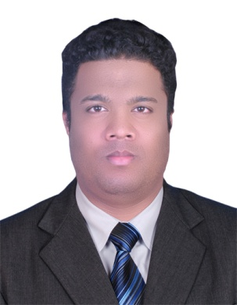

Mohammed

Email : mohammed.370711@2freemail.com

ARMED FORCES OFFICERS CLUB & HOTEL

Abu Dhabi, U.A.E

OBJECTIVE

To use my knowledge to better the environment and to obtain a position in field of Hotel Management & Catering Technology.

EDUCATION

• ASIAN LANKA HOTTEL INSTITUTE (2006 TO 2007)

- HIGHER SECONDARY BOYS HIGH SCHOOL COLOMBO

TRAININGS COMPLETED

- Essential Food and Safety (Abu Dhabi Food Control Authority Certificate)

- CUSTOMER SERVICE (MAFRAQ HOTEL ,Abu Dhabi
- American heart association first aid (abu dhabi)

- Chemical Handling Training (Mafraq, Abu Dhabi)

- Basic First Aid Training (Mafraq Abu Dhabi)

- HACCP Concepts (Mafraq, Abu Dhabi)

WORKING EXPERIENCE

1. YADOOS HOUSE RESTOURANT( ARBIC TRADISINAL ) Abu Dhabi

Designation: Demi chef Duration 2014 to 2015

WORKING EXPERIENCE

1.MAFARQ HOTEL

Abu Dhabi
Designation: COMMI 2 .

Duration: From October 2010 to2012 Responsibilities
- Managed food preparation processes.
- Managed all team tasks.
- Coordinated with front-of-house staff.
- Checked garnishes and meal presentation.
- Checked and maintained stock levels.

- Helped manage all staff rosters.

- Assisted the head chef de cuisine with menu planning, budgets and wine

selection Achievements

  - Second place in the Restaurant and Catering Association Apprentice Cookery
_________________________________________________________________

_

- HH SHIEK HAMDAN BIN ZAYED ALL NAHYAN PALACE

(Location ABU DHABI )

Designation: COMMI 1

Duration: From August 2012 to 2014.

Responsibilities

  - Goal oriented individual with strong leadership capabilities.

  - To maintain the quality and presentation of all food served and Checking and Maintaining the Daily Time-Sheet.

  - Giving feedback of Daily Production of hot food & salads or cold food to Sous Chef and generating food count reports.

  - To maintain the quality and presentation of all food served.

  - Good team work .

- Bentata beach hotel

Designation: COMMI 3
TECHNICAL KNOWLEDGE

- Computer Application.
- EFST (Essential Food Safety Training, Abu Dhabi)

LANGUAGES KNOWN

English, Hindi, Malayalam, Arabic, Tamil
PERSONAL DETAILS
Date of Birth/Age | : | 12-11-1985 / 32
Sex | : | Male
Religion/Caste | : | Islam
Nationality | : | Srilankan
Marital Status | : | Married
Place Of Issue | : | Srilanka
Current Location | : | Abu Dhabi, UAE
Place: Abu dhabi |  |  | Signature
Date : |  |  | Mohammed

