PERSONAL INFORMATIONS | Mohammed
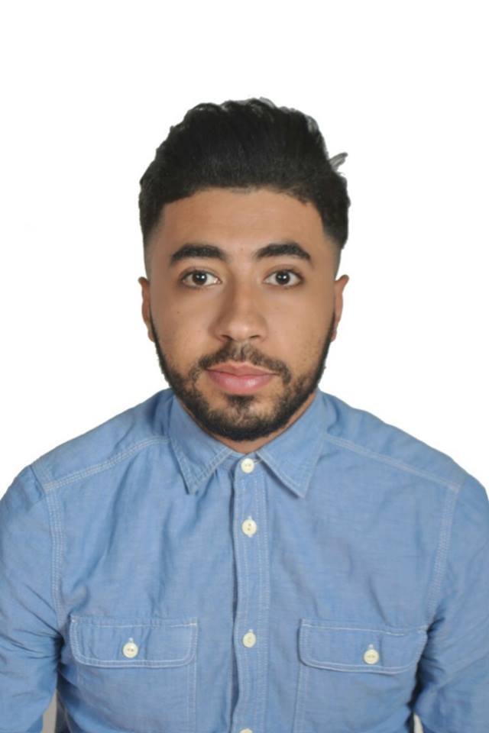
mohammed.370722@2freemail.com

I am seeking employment with a company where I can use my talents and skills to grow and expand the company, as well as I want to succeed in a stimulating and challenging environment, building the success of the company while I experience advancement opportunities.
 | Sex Male | Date of birth 12/11/1994 | Nationality Algerian

WORK EXPERIENCE

From 2012 to 2013  From 2013 to 2015  From 2015 to 2016 | Electronics seller
 | Private
Cyber Coffee Manager
Private
Hotel Receptionist
Nedjma Hotel
From 2016 to 2017 | Administrative executive  Nedjma Hotel

EDUCATION AND TRAINING

From 2010 to 2013 | Scientific Branch baccalaureate
 | Hassini Hocine Secondary School ( Algeria )
From 2013 to 2016 | Licence Degree ( English Language )
 | Djilali Liabes University of Sidi Bel Abbes ( Algeria )
From 2016 to 2018 | Preparing My Master Degree ( Didactics Of Literature,Civilization and Discourse Analysis )
 | Djilali Liabes University of Sidi Bel Abbes ( Algeria )

PERSONAL SKILLS

Mother tongue(s) | Arabic
Other language(s) | UNDERSTANDING |  |  |  | SPEAKING |  |  |  | WRITING
 | Listening |  | Reading |  | Spoken interaction |  | Spoken production
Arabic | C |  | C |  | C |  | C |  | C
French | C |  | C |  | C |  | B |  | C
English | B | B |  | B |  | B |  | C
Spanish | A | A |  | A |  | A |  | A

Communication skills | - good communication skills gained through my experience

Digital competence | - competent with most Microsoft Office programmes (word processor, spread sheet, presentation software)  - Data entry clerk , billing , business cards and invitations  - Hardware Maintenance  - good command of photo editing software gained as an amateur photographer

Other skills | - Creating pieces of Art and visiting Modern Art galleries. Enjoy all sports particularly Tennis, football and running. Love to experience different cultures

Driving licence | A - B

Open to relocation

