Vishnu 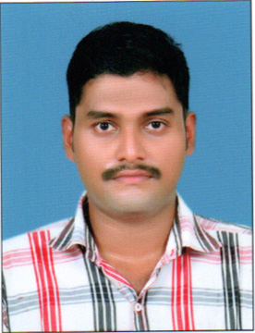•
E-MAIL Vishnu.370724@2freemail.com

OBJECTIVE To secure a promising, successful and challenging career in a reputed organization where my knowledge and skill can be effectively applied which will enable me to explore myself and realize my potential.
EDUCATION ITC in Electrician

NCVT, V Institute, Kollam
2007- 2009 with 60%

Higher Secondary Education
Board of Higher Secondary Campus College, Kollam
2007 with 72 %

Secondary School Education
Kerala Examination Board, Government HSS, Kollam
2005 with 60 %

TOTAL EXPERIENCE :5 YEARS

- Experience of 4 Years as Electrician At Al-Mukhaini International TRAD & Cont. LLC , Oman from February 2013 to March 2017

- Electrical installation experience in an industrial environment.

- Ability to work in a fast paced environment.

- Estimating both small and large scale electrical works.

- Ability to identify opportunities to reduce costs and improve efficiency.

- Negotiating with sub-contractors.

- Aiming for complete customer satisfaction whilst remaining commercially aware.

- Never giving up until a job is completely done.
- Experience of 1 year as Electrician At Indian Rare Earth Limited , Chavara from February 2011 to February 2012

AREAS OF EXPERTISE

Electrical installations

Electrical drawings

Panel drawings

Electrical specifications

Electrical networks

HOBBIES Reading, Writing Poems and short stories & Travelling
PASPORT DETAILS
Date of Issue : 22/09/2011
Date of Expiry : 21/09/2021
Place of Issue : Trivandrum
PERSONAL DETAILS
Name : Vishnu VG
Date of Birth/Age : 7th September 1988/29 Years
Email : Vishnu.370724@2freemail.com

DECLARATION
I hereby confirm that all the information provided above is authentic to the best of my knowledge.

Vishnu
E-MAIL Vishnu.370724@2freemail.com

