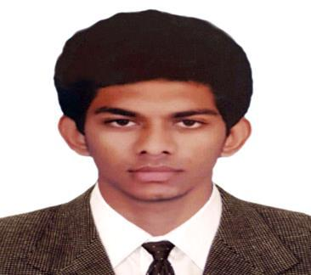

AKSHAY

EMail: akshay.370726@2freemail.com

KEY QUALIFICATION

A qualified safety professional administering Project Environmental Health and Safety policies focusing on potentially hazardous operations and emphasizing proactive solution. Approved HSE Officer Lloyds line Pipe Ltd, Lloyds Steels(Mumbai), about 1 years of solid experience in managing Health, Safety and Environmental aspects on large scale construction projects.

PROFESSIONAL ACHIEVEMENTS:

- Graduate in BE Mechanical Engineering

- Graduate member of IOSH (Institute of Occupational Safety and Health)

- Diploma in occupational health and safety

- Successfully completed NEBOSH (International General Certificate in Health and Safety)

TRAINING DESCRIPTIONS:

- Fire warden.

- Basic first Aider.

- Accident Investigation.

ACADEMIC ACHIEVEMENTS:

2011 – 2015 – Nehru Institute of Engineering and Technology, Coimbatore

- Mechanical Engineering – 68%

2009 – 2011 – Mambaram Higher Secondary School, Mambaram

- +2 – 82%

2008 – 2009 – Mambaram Higher Secondary School, Mambaram

- S.S.L.C – 87%

PROFESSIONAL EXPERIENCE

Employer | : |  | Lloyds line Pipe Ltd, Lloyds Steels(Mumbai
Period | : |  | May 2015 to September 2016
Position | : | Safety Officer

Responsibilities:

- Follow and implement company HSE policy and plan at the site.
- Assisting the HSE Manager in coordinating all HSE activities.
- Carry out regular site safety inspections and submit reports.
- Render necessary advice to engineers/supervisors / workers during HSE inspections.
- Preparation and Submission of daily, weekly and monthly reports.

- Assist the HSE Manager in analysing accident/incident records and make investigation.

- Report and investigate all Near Misses, Incidents, and Accidents and identify the root cause and take necessary steps to eliminate dangers and recurrence
- Cooperate with client’s/ consultants HSE representatives.
- Ensure the Company Health & Safety, & Environmental is to the best achievable standard
- Participate on the site HSE executive committee & meeting.

- Set a high example of health and safety at all times

- Co-ordination with Clients and contractors

- Understanding of the contract requirements and communicating them to the project team.

- Formulate new safety measures on need basis and review its performance.

- Participate and carryout all emergency drills.
- Reinforce safe behaviour and corrects unsafe behaviour.

CERTIFICATION:

- IOSH Managing Safely, UK Certificate.

- NEBOSH course competed successfully.

- Diploma in Occupational Health and Safety.

- Automation Tools specializing PLC, DCS, SCADA and VFD

SKILLS

Microsoft office suite

Product knowledge

Quick learner

Organizational skill

Problem solving

PERSONAL INFORMATION

Nationality | : | Indian
Date of Birth | : 18-02-1993
Sex | : | Male
Marital Status | : | Single
Languages known | : | English, Hindi, Malayalam, Tamil.
Visa Status | : | Tourist Visa

DECLARATION

I hereby declare that the above given information is true to best of my knowledge.

AKSHAY

