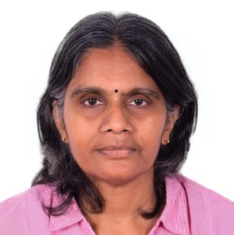
RESUME
Name : Lakshmi
Date of Birth : 27/08/1958
Sex : Female
Nationality : Indian
Marital Status : Married

Qualification : i) M.Sc in Mathematics in the year 1980 with an outstanding grade from the University of Madras.
ii) B.Ed., with a first class From Annamalai University.
Experience : In all more than 22 years of teaching
- 2012 – 2015, 3 years in a reputed British Curriculum school, Dubai. Classes Handled: X, XI, XII Responsibilities Regular Teaching, Setting questions for high achievers, coaching average students, lesson planning.
- 1998 - 2011, about 12 years in Abu Dhabi Indian School, Abu Dhabi.
Designation: PGT Classes Handled: XI, XII
Member of the Examination Committee. First coordinator of Grade 10 Board Examinations.
- 1991 - 1998, 7 years in Adarsh Vidyalaya Matriculation Higher Secondary School, Chennai, Tamil Nadu. Classes Handled: XI, XII
Responsibilities Teaching, Lesson Planning.
Other Details :
Mail Id : Lakshmi.370738@2freemail.com
Passport Expiry : 28/10/2024
Visa Status : Residence
Visa Expiry : 19/10/2017

-------------------------------------------------------------------

Reference on request
Will be able to teach any branch of Mathematics till graduation level.
Prepared to take a demo without notice.
Confident of delivering good lectures.

