Aly
Personal Data:
Birth Date: 15/8/1982
Gender: Male
Social Status: Married
Nationality: Egyptian
Email: aly.370739@2freemail.com

Languages & Computer:
* Proficiency in Arabic and English with a simple knowledge of French.
* Excellent proficiency in dealing with all computer hardware and software and the ability to solve all problems in both.

Programs:
AutoCAD – Pro Link – Civil – Land – Surfer

Devices:
Level – Total station – Gps – Echo Sunder

Companies already operating:
- Gulf Survey Business Office (Tanta – Egypt)
- Road net Contracting Company (AL Riyadh – KSA)
- Ostorat Al E3mar Contracting Corporation (Jeddah – KSA)
- Rawafed Al Torok Contracting Corporation (AL Riyadh – KSA)
- Rolla Contracting Company (Cairo – Egypt)

Projects:
- Ashmoun sewage network project in Egypt with the teamwork of Gulf Business Survey Office between 14/9/2011 to 20/2/2012.
- Asphalting project of Hofuf plans – AL Hasa – eastern region- KSA, with the teamwork of Road Net Contracting Company between 5/6/2013 to 20/1/2014.
- Asphalting project Al-Zaher Road in Al-Kharj KSA with a length of 4200 meters and a width of 33 meters, with side pavements and lighting poles of 25 meters. All this with the teamwork of Road Net Contracting Company between 21/1/2014 to 30/9/2014.
- Wadi Al-Solei torrents drainage project in AL Riyadh KSA with a length of 100 km and width of 24 meters at the top and 12 meters below and depth of 12 meters and side slope 2:1. All this with the teamwork of Rawafed Al Torok Contracting Corporation between 15/10/2014 to 15/3/2015.
- The drainage network project for Al-Faisal plan in Makah on an area of 3 million square meters with the teamwork of Ostorat Al E3mar Contracting Corporation between 25/3/2015 to 15/9/2015.
- Domestic sewerage connection project Haql city KSA – installation of 800 manholes with a diameter of 60 cm plus 200 manholes with a diameter of 90 cm with installation of polyethylene pipes diameters 6 and 8 inches ... All this as chef surveyor with the teamwork of Ostorat Al E3mar Contracting Corporation between 16/9/2015 to 15/5/2016.
- Project of reducing the level of the bottom of Al Manzala Lake in Ras al-Bar city at a depth of 2.5 meters with a length of 7200 meters and width of 492 meters and a cost of 107 million pounds with the teamwork of Rolla Contracting Company between 15/7/2016to 1/4/2017.

Skills:
*Ability to manage all work sites and face the most difficult problems with wisdom and control of administrative and financial matters.
* Adapt to all available working conditions, whether climatic, psychological or financial, no matter how difficult they are.

* Commitment to work requirements, conditions and times, as well as writing reports, obeying the site managers and fulfillment instructions.
* Ability to drive all kinds of cars and some work machine.
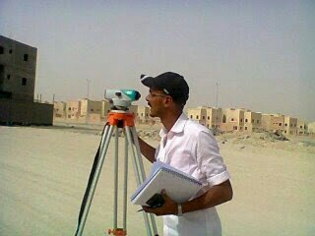
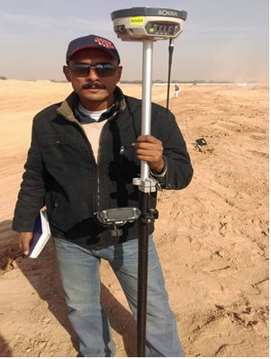

Wadi Al-Solei - AL Riyadh – KSA Hofuf plans – AL Hasa – eastern region KSA
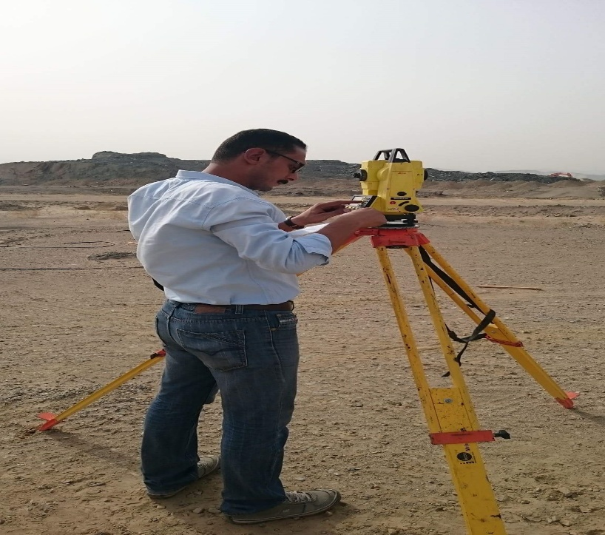
Al Faisal plan – Makah - ksa

Finally, I will be happy to cooperate with your esteemed company

