JISON.  Jison.370747@2freemail.com  Qualification  B.Pharm.  Permanent Address  jisonpj1993@gmail.com  Personal Data  Father’s Name : Jose  Sex : Male  Nationality : Indian  Marital Status : Single  Mother Tongue : Malayalam  Religion : Roman  Catholic  Passport details  Language Proficiency  English,Malayalam,Hindi  Other Interests  Reading,Playing Football | RESUME  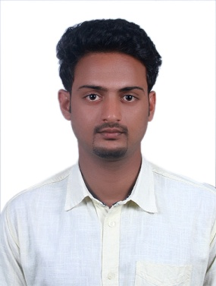  Objective  - Aiming at excellence in the working field through hard work, dedication and honesty at challenging environment.  Education  B.Pharm: (Bachelor Of Pharmacy) : 70%  Rajive Gandhi University,Manglore  From: Karavali College Of Pharmacy(2010-2014), Manglore,Karnataka.  H.S.C (2010): 70%  S.S.L.C (2008):78%  Experience  - two year experience as a Pharmacist in West fort hi-tech hospital, Thrissur  2 currently working in life pharmacy , dubai  Declaration  I hereby declare that the above-mentioned details are true to the best of my knowledge.  Place:dubai  Date:  Thanking you and awaiting your favorable reply.  JISON

