CURRICULUM VITAE

AMIT
amit.370758@2freemail.com
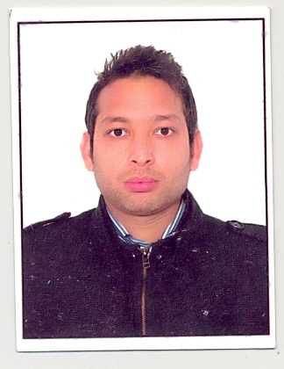

OBJECTIVE

To add innovative ideas to the work, I do for achieving organizational goal and to have a continuous
Self-development by way of learning and exposure to new assignment.

SUMMARY OF SKILLS AND EXPERIENCE

A result oriented professional with 10 years (approx) of experience in Automobile Service.
Currently working with N.B.H.H (construction company) in Workshop Service Department

WORK EXPERIENCE

- Presently working As Supervisor in NAEL & BIN HARMAL HYDROEXPORT.
From 11-2-2014 till date.

- Key Function and responsibility as a Service Advisor:-

- Receiving vehicle in workshop which comes for service and repair.
- Opening Job Cards.
- Resolving all kind of Queries & Requirements of the customers relating to the vehicle.
- Solely responsible for resolving all kinds of complaints received from the customer with in service levels.
- Making calls to customers for PSF (Post Service Follow-up) & IFC (Instant Feedback Card) dissatisfied customers complaints, closed in defined time frame, maintaining proper records.
- Preparation and submission of various Advisor’s Activity reports on daily and monthly basis like CSI Report (On Fortnight Basis), IFC, SSS, JDP,
- Home Visits for dissatisfied Customer’s if required.

- Worked with Modern Automobiles Authorized Dealership of Maruti Suzuki as a Technician from Feb. 2007 to June 2008.and worked as workshop supervisor from June 2008 to July 2010.
- Basic and Advance Training by Maruti Suzuki at Ludhiana (india).
- Worked in Dynamic Motors as a service advisor( Authorized Dealership of CHEVROLET) August 2010 –August 2012
- I had cleared 8 training of Chevrolet, as per details given below,
- Service Advisor Module 1 and Module 2
- M.D.I--- Multiple diagnostic Interface Familiarization.
- Understanding the value of Customer Enthusiasm, Fix first Right Time & Customer Satisfaction, after sale Commercial training.
- Worked with Tricity RENAULT (Authorized dealership of Renault) August 2012-August 2013.
- BRONZE Level Certification Assessment for Service Advisors, & Silver Level Certification Assessment for Service Advisors.

- Valid Light motor vehicle license of U.A.E.

KEY RESULT AREA

- Target Achiever
- Result oriented
- Proactive and go-getter
- Always commanded respect from juniors & seniors alike

ACADEMIC QUALIFICATION

- Graduation From Panjab University, Chandigarh

PROFESSIONAL QUALIFICATION

- ITI (Automobile Engineering) from Chandigarh.
Diploma in mechanical Engineering from IASE University.

COMPUTER KNOWLEDGE

- Office Tools: - MS Word, MS Excel, MS Power Point
- Communication Tools: - E-mail.

PERSONAL DETAIL

- Father’s Name : Kamal Kant Dhiman
- Language known : English, Hindi, Punjabi
- Interest and Hobbies : Listening to music, Travelling and Reading
Books

Date :

Place : U.A.E

