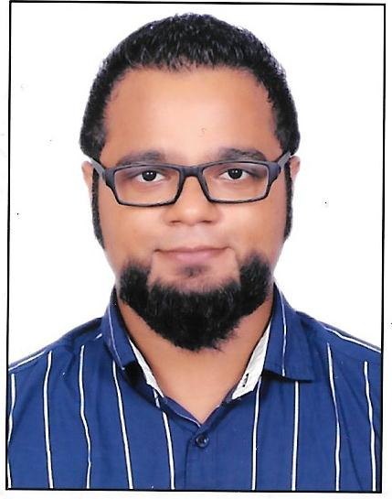

Sean
Sean.370759@2freemail.com

Career Objective

To obtain a challenging position that allows me to utilize my talent and expertise in an environment conducive to continual advancement of knowledge and skill. A leader with decision making skills and ability to identify areas requiring change.
Employment History

Nael & Bin Harmal Hydroexport Est. (Al-Ain, UAE.) 2016 - Present (Position downsized)
Workshop – Timekeeper/Coordinator/Asst. Administrator
Being a leading construction company in the UAE, it has a fleet of over 3,000 vehicles and equipment.
It has its own workshops across the Emirates for regular maintenance and repairs.
- Handle the new employee joining process and arranging for their accommodation
- Generate daily and monthly attendance report of about 150 employees.
- Prepare overtime report to be reviewed before the final approval from the manager.
- Manage leave application, resignation and terminations
- Document control and data processing
- Handle petty cash and maintain the daily expenses report
- Update appointment calendars’ and schedule meeting/appointments for the manager
- Dealing with emails and often corresponding on behalf of the manager
- Maintain breakdown vehicle inventory and communicating the issues with the garage foreman
- Generating timesheet for about 120 vehicles and transfer them to different projects as directed by the management
- Ordering parts and materials
- Coordinating with the central store for parts and materials

Serco Global Services (EasyJet Airline Process)______ ____ 2013 - 2015
Senior Customer Service Advisor
- Worked for both voice support and back office
- Advised travel plans, airline policies and often travel document requirements
- Made reservations on DOS based system
- Made amendments in the itinerary
- Assist customers facing technical difficulties on the website and mobile application
- Dealt with compensation and reimbursement claims in case of flight delays, cancellations and denied boarding; often denied compensations keeping in line with the EU regulations
- Corresponding to customers’ queries and complaints by email
- Underwent training in email writing skills
New Life Fellowship Association (Mumbai, Maharashtra, India.) 2011 - 2013

Administrator for Youth Education

An NGO run by the church organization offering pre-primary education (Balwadi) to the

underprivileged and weaker section of the society.
- Manage monthly budget and finance for five branches
- Manage staff schedules and monitor operations
- Prepare reports and updating the management on a daily basis
- Communicating instructions from the management to the staff
- Keeping a record of daily attendance of students
- Order stationery, study material and food supplies
- Procuring Sponsorship from missionaries
- Arranging accommodation for missionaries

Education

2012 | Bachelor in Mass Media (B.M.M.) - Mumbai University.
 | Lord’s Universal College, Mumbai, India.
2009 | H.S.C. - NIOS Board
 | Lord’s Universal College, Mumbai, India.
2007 | S.S.C. – Maharashtra State Board
 | Holy Family Convent High School, Mumbai, India
Computer Skills

MS- Excel, MS- Word and Power Point, Oracle JD Edwards/Kana/MS DOS (user level)

Professional Efficiency
- Self-motivated, independent and highly professional
- Excellent communication, negotiation and interpersonal skills - spoken and written
- Administration and customer service skills
- Adaptable to change and challenges
- Open attitude towards learning
- Creative and problem solving skills
- Flexible team player

Personal Details

Marital status : Single
Languages : English, Hindi, Marathi and Konkani
Hobbies : Travelling, adventure, sports, playing musical instruments
Visa Status : Employment

