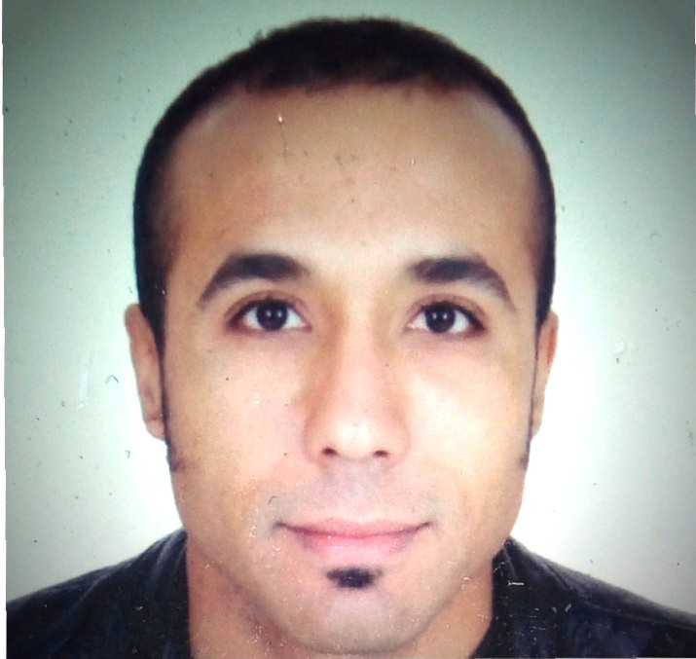

EMPLOYMENT
September 2014 –May 2017
Manager at Dream-café – Casablanca, Morocco

Responsibilities
- Make sure operation is smooth.
- Provide trainings for waiters in coffee making and customer service techniques.
- Managing wastage and cost
- Managing inventory and all related tasks
Achievements
- Improving staff efficiency
- Promoting coffee making techniques resulting in better coffee drinks
- Reducing wastages through proper ordering
- Controlling costs and achieving contribution

March 2013 – June 2014
Coffee section Manager at Cooma Pies Café – Cooma NSW, Australia

Responsibilities
- Preparing and serving drinks as per the outlet standard
- Maintaining coffee machine and all related equipment
- General Stock ordering
- Performing section inventory
Achievements
- Improving coffee quality and service speed
- Increase coffee sales
- Serving all customer in peak hours without losing any and without risking drinks quality

March 2010 to June 2012
Outlet Manager - Café Nero – www.caffenero.com -
Abu Dhabi - UNITED ARAB EMIRATES

Responsibilities
- Ensuring outlet operations and brand guidelines are adhered to as required by the company and franchise standards
- Overseeing system transactions and controlling voiding system, opening and cash out procedure, system reconciliation and daily banking procedure
- Prepare monthly sales reports, weekly profit and loss statements and provide relevant feedback and suggestions to the Area Manager to maximize operational efficiency
- Seek new opportunities to drive and create additional sales
- Perfect management of stock levels to ensure smooth running of operations to cater to customer demands
- Maintain hygiene standards and monitor regular quality checks for the outlet
- Organize staffing requirements to ensure the right caliber and mixture of staff is selected to meet company objectives. Also manage staff schedules to ensure optimum staffing at all times
- Communicate effectively with the team, passing on all relevant information at the appropriate time
- Guide, instruct, develop and motivate staff to achieve their objectives, work to their optimum potential and ensure effective performance

Achievements
- Minimizing transaction voids and maintaining safe cash management
- Superior customer service with the flow on effect of maintaining and increasing and number of regular customers
- Outlet quarterly awards in cost control and waste management
- Follow up on local surroundings and increase sales opportunities by creating office deliveries
- Reducing inventory gaps through comprehensive understanding of materials control system
- First store in second cupping sales
- Increased store sales by 20% based on like-for-like sales
- Good follow up on succession planning and staff development, resulting in a promotion of 2 Baristas to Shift Leaders, and 2 Shift Leaders to Assistant Manager positions
- Passing Café Nero Brand Audit in Health and Safety, Financial and coffee standards
- Passing Coffee Maestro test as per Café Nero Standard

May 2006 to June 2009
Outlet Manager - Costa Coffee- www.costacoffee.ae
Abu Dhabi - UNITED ARAB EMIRATES

Responsibilities
- Training staff on coffee preparation and leading by example
- Perfecting team arrangement as per performance and level of business
- Updating the team on latest emails and changes either in products or service
- Focusing on succession planning and staff development
- Decreasing transaction voids through efficient upselling skills and menu knowledge
- Working on coffee and food margins and minimizing wastage
- Ensuring all customers are satisfied with service and product
- Ensuring Costa standard is followed and mistakes minimal in peak hours
- Ensuring mystery shopper results were mostly positive and reflecting the good experience offered to customers

Achievements
- Working on effective succession planning and people development resulting in promotion of three supervisors from lead Barista position
- Increasing the team awareness about sales opportunities and customer satisfaction which increased sales by 50% and advancing the outlet type from medium to high volume store
- Good analysis of profit and loss sheets resulting in elevated bottom line
- Building international Costa Café standard to a higher level by passing Costa health and safety and financial audits
- Achieving good mystery shopper results
- Attaining external catering opportunities – Etisalat Abu Dhabi Catering
- Perfect control of finished product wastage through good inventory management

August 2003 to April 2005
Waiter - Sofitel City Centre Hotel & Residence - www.accorhotels.com
Dubai - UNITED ARAB EMIRATES

Responsibilities
- Providing excellent customer service to hotel guests
- Upholding the hotel brand standard
- Full knowledge of the food and beverage menu
- Phone order taking
- Set up and delivery of orders to guest rooms in an efficient and professional manner
- Manage customer complaints
Achievements
- Positive feedback from guests about service quality and assistance
- Promotion to a solo shift waiter in the VIP executive lounge
- Exceeding the job role and providing assistance to other outlets – either bars or restaurants
- Providing assistance to inside and outside catering

TRAINING & DEVELOPMENT

- Health & Safety Training - Al Tayer Head Office, Dubai
- Materials Control and Inventory Training course, Al Tayer Head Office, Dubai
- Team Appraisal Training Course, Al Tayer Head Office, Dubai
- Coffee machine monitoring and maintenance, Bon Café, Dubai.
- 2006: coffee excellence; store management; upselling; food and hygiene; merchandizing MMI, Dubai.
- 2005: training as agent in Media Plaza, Casablanca.
- April 2004: Training in telephone skills. Sofitel City Centre, Dubai.
- April 2004: Training in fire fighting skills. Ministry of Defence, Dubai.
- 10th October-26th December 2004: Cross Training as reservation agent in the Sales and Marketing Department. Sofitel Hotel. Dubai
- March 2004: Food and Hygiene certificate. Chartered Institute of Environmental Health, Sofitel Hotel, Dubai
- February 2004: First Aid Training Course, Government of Dubai
- 1st September 2001- 1st January 2002: Word, Windows and Excel training; Al Bir Association, Casablanca.

EDUCATION

- 1994 Baccalaureate in Modern Languages and Literature Ibnou Hazm Secondary School. Casablanca, Morocco
- 2001 Bachelor of Arts in English Literature and Linguistics
- Hassan ll University. Casablanca, Morocco.

LANGUAGES

- Arabic
- English
- French

Visa Status: visit visa till the 9th of September 2017

