CURRICULUM VITAE
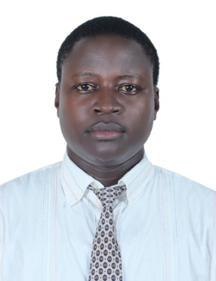
wakadala.370814@2fremail.com

Name: Wakadala
Nationality: Ugandan
Visa Status: Visit Visa
Language: Native English Speaker,

Objective
A dynamic smart versatile, interactive person with a professional background seeking for placement in your collaborative and challenging environment where integrity and cooperate governance are highly valued with objective to improve my career.
Educational Background
Ugandan Advanced Certificate of Education - 2005 - 2006
Ugandan Certificate of Education - 2001- 2004
Working Experience
Amazon Hotel Entebbe (Uganda) Receptionist Security – 2014- 2017
(Duties and responsibilities)
- Welcomes visitors by greeting them, in person or on the telephone, answering or referring inquiries.
- Directs visitors by maintaining employee and department directories, giving instructions.
- Maintains security by following procedures, monitoring logbook, issuing visitor access badges.
- Serves as first hand support to ATMs and check deposit,
- Ensures adequate teller sequence.
- Making reports of all anomalies to both CBD Property Facility’s managers and third party vendors

Travel in Restaurant Entebbe (Uganda) – Cashier - 2013 -2014
(Duties and responsibilities)
- Handle cash transactions with customers
- Scan goods and collect payments
- Issue receipts, refunds, change or tickets
- Redeem stamps and coupons
- Make sales referrals, cross-sell products and introduce new ones
- Resolve customer complaints, guide them and provide relevant information
- Greet customers when entering or leaving establishments
- Maintain clean and tidy checkout areas
- Keep reports of transactions
- Bag, box or wrap packages
- Pleasantly deal with customers to ensure satisfaction.
Nile Breeze Hotel Jinja (Uganda) –Waiter /Bellboy 2010-2013
(Duties and responsibilities)

- Prepare tables for meals, including setting up items such as linens, silverware, and glassware
- Remove dishes and glasses from tables or counters, take them to kitchen for cleaning.
- Assist host or hostess by answering phones to take reservations or to-go orders, and by greeting, seating, and thanking guests.
- Perform cleaning duties, such as sweeping and mopping floors, vacuuming carpet, tidying up server station, taking out trash, or checking and cleaning bathroom.
- Bring wine selections to tables with appropriate glasses, and pour the wines for customers.
- Perform food preparation duties such as preparing salads, appetizers, and cold dishes, portioning desserts, and brewing coffee.
- Escort customers to their tables.
- Garnish and decorate dishes in preparation for serving.
- Fill salt, pepper, sugar, cream, condiment, and napkin containers.
- Describe and recommend wines to customers.
- Provide guests with information about local areas, including giving directions

Knowledge and Ability

- Ability to close deals.
- Ability to work individually and within a team.
- Flawless trouble shooting technics.
- Always willing to learn and adapt very fast.
- Honest, hard worker and committed.
- Excellent communication skills.

Trainings and Skills acquired (Professional background)

- Vest with modern techniques, Technologies and best practices.
- Excellent communication skills.
- Always professional in all my endeavors.
- Team Player
- Having a friendly and engaging personality.
- Comfortable working with members of the public.
- I have a confident manner.
- I am helpful and polite.
- Always physically fit because I will be on my feet for most of the day and may be required to lift large amounts of stock.
- Possesses a comprehensive understanding of my area and line of duties.
- Knowledge of inventory techniques.
- Above all, I am smart in appearance and very articulate.

Hobbies
Researching Reading intelligent journals
Reference
Provided upon request
Declaration
Wakadala

