CURRICULUM VITAE

GODVRIED

Email: godvried.370848@2freemail.com
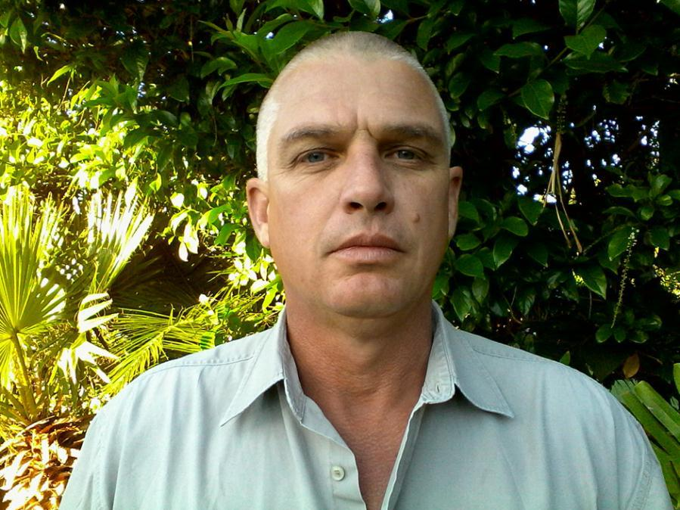

A. RELEVANT ADDRESS

RESIDENTAL ADDRESS:

B. PERSONAL PARTICULARS

DATE OF BIRTH:

AGE:

SEX:

MARITAL STATUS:

NATIONALITY:

HOME LANGUAGES:

OTHER LANGUAGES:

DRIVER’S LICENCE:

HEALTH:

CRIMINAL OFFENCES:

CHURCH DENOMINATION:

23 October 1969

47

Male

Married

Citizen of the Republic of South Africa

Afrikaans/English

No

Code A & EC (Code 14)

Good

None

Methodist

C. EDUCATIONAL QUALIFICATIONS

SCHOOL:

HOER TEGNIESE SKOOL

DANIEL PIENAAR

UITENHAGE

Eastern Cape

(1985 – 1987)

HIGHEST STANDARD OBTAINED:

Matric

SUBJECTS DONE AT SCHOOL:

Afrikaans First Language Higher Grade English First language Higher Grade Technical Drawings Standard Grade Woodwork Standard Grade Mathematics Standard Grade Science Standard Grade

LEADERSHIP:

Rugby Captain

EXTRAMURAL ACTIVITITIES:

Cycling / Squash

ACHIEVEMENTS:

Woodwork Diploma

D. TERTIARY EDUCATION

INSTITUTION:

Port Elizabeth Technikon (1995 1st year)

SUBJECTS:

Building Science

Construction Management

Construction Technology

Quantity Surveying

Field surveying

Communications

Computer Applications

E. COURSES

DEPARTMENT WATER AFFAIRS & FORESTRY:

Three year Departmental certificate course qualifying as Survey Officer successfully completed in 1993

CAPE PENINSULA UNIVERSITY OF TECHNOLOGY:

Successfully completed a course in Hydrography 2.

UNIVERSITY OF STELLENBOSCH:

Successfully completed a course in

Dam Monitoring and Surveillance.

GIMS:

Successfully completed a course in

Introduction GIS & Arcview GIS.

EASTCAPE TRAINING CENTER:

Chain saw operators course.

SOUTH AFRICAN MARITIME SAFETY AUTHORITY:

Certificate of competence. Day skipper limited to 15 miles from shore.

F. NATIONAL SECVICE

BASIC TRAINING:

South African Armoured Division

ACHIEVEMENTS:

Corporal Crew Commander

G. EMPLOYMENT HISTORY

NAME OF ORGANIZATION:

Department Water Affairs and Forestry (1990 – 1995) (1999 – 2014)

TYPE OF ORGANIZATION:

Government

POSITION HELD:

Principal Survey Officer

KEY RESPONSIBILITIES:

To collect field data with a range of survey instruments in various types of surveys, from which a plan is constructed according to the survey standards and requirements and to complete a report for all projects on completion.

Human Resource Management – Training and development of junior personnel so that the competency level complied with policies and timeframes.

Supervise personnel during field work, to convey a positive attitude to work productively and to med work program timeframes.

Capacity Surveys – Examples; rural supply dams, farm dams and municipal supply dams. The main purpose for capacity surveys is to calculate accurate volumes for future planning.

Field surveys and the processing of data. The quality of the task is measured against set survey standards and accuracies. Output is a contour plan, capacity table, cross sections as

required and final report with job specific software and hardware. Duration of task is measured against survey work program.

Instruments used in these projects will be a boat fitted with Hypack survey program, single beam echo sounder and GPS. A sound velocity probe is also used to measure water temperature and salinity. The dry work from edge water to full supply and above, dam wall detail included is measured with Trimble RTK GPS, Sokkia set 5 and Trimble S6. Levelling of control points is also done.

Topographical and detail surveys – Examples; hydro river weirs topographical and as builds for calibration. To synchronise outlet valves, outlet towers and spillways on reservoirs to gauge plates readings with capacity table. Refurbishment of dam walls, water canals and syphon pipe lines. Topographical and detail surveys for new development constructions, excavations, setting out of structures and pipe lines. Survey of rivers and estuaries for monitoring the siltation process dew to the man build obstructions in the rivers like bridge towers and dam walls.

Field surveys and the processing of data. The quality of the task is measured against set survey standards and accuracies. Output processing field survey data creating a detailed contour plan with long and cross sections as required and final report using job specific software and hardware. Duration of task is measured against survey work program.

Instruments used for this type of surveys will be Sokkia set 5, 30R, Asthech Promarks, Trimble RTK GPS, Trimble S6 and levelling of control points.

Deflection surveys – Examples; Kouga Dam, Kat River Dam, Laing Dam, Impofu Dam, Poortjieskloof Dam, Duiwenhoks Dam, Roode Els Berg Dam, Vanderkloof Dam, Korentepoort Dam, Hartebeeskuil Dam, Clanwiliam Dam, Bulshoek Dam. The main purpose of deflection survey is to monitor the constant movement of structures (Dam walls) between seasons. It also must be done to comply with dam safety and regulations to reservoirs with a certain capacity.

Field Surveys consists of precise levelling, precise traverse with distances and network with distances. Data accuracies are measured by set standards and comparison of previous surveys. Completeness of a task is the processing data with job specific software and hardware consists of horizontal, vertical directions final and final heights comparison. Instruments used for these types of surveys are Leica TDM 5000, TDA 5005 and for precise levelling Jena 500 and Trimble electronic

Hydrographical surveys - Examples; Kouga Dam, Kat River Dam, Laing Dam, Impofu Dam, Poortjieskloof Dam, Duiwenhoks Dam, Vanderkloof Dam, Korentepoort Dam, Hartebeeskuil Dam, Clanwiliam Dam, Bulshoek Dam, Grassridge Dam, Darlington Dam. The purpose of hydrographical surveys is to monitor volumes in big water supplied dams and the siltation process and for future planning.

Field surveys and the processing of data. The quality of task is measured against set survey standards and accuracies of final section data and completeness of report. Field surveys (Water and Dry Work) consists of data collected on predetermined sections between two fixed points for entire basin up to outside full supply and flood range. Section data is calculated and check against previous section data with job specific software and hardware. The duration of the task is measured against survey work program. Instruments used in these projects will be a boat fitted with Hypack survey program, single beam echo sounder and GPS RTK with base station on a fixed beacon. A sound velocity probe is also used to measure water temperature and salinity. The dry work from edge water to permanent fix beacons for every section and above is measured with Trimble RTK GPS, Sokkia set 5, 30R and Trimble S6.

Office duties – to manage and maintain all equipment under my control.

the management and control of six (6) personnel members.

the training of junior surveyors both theoretically and practically.

the calculation of field data to produce a final product with a detailed report.

The computer software that is used for the above task is Model Maker, Road Maker, Trimble Office, Hypack and Window Office.

REASONS FOR LEAVING: I reached a level in my career was I stagnated. Went into an existing transport business with my brother 2014 to date.

NAME OF ORGANIZATION: |  | Power Construction
 |  | (1996)
ADDRESS OF ORGANIZATION: |  | Blackheath Western Cape
TYPE OF ORGANIZATION: |  | Private Sector
POSITION HELD: |  | Chief site Surveyor (Transkei Emergency School extensions)
KEY RESPONSIBILITIES: |  | Topographical surveys – Field surveys and managing of all
 |  | cut and fill earthworks. To locate site and negotiate with
 |  | community to determine best position for construction.
 |  | Setting out of the construction area with levels for cut and
 |  | fill excavation to create building platform. Placement of final
 |  | foundation pegs. To relay cut and fill data volumes to
 |  | quantity surveyor. Managing the movement of the
 |  | equipment threw the Transkei to various construction sites.
 |  | General administration for equipment and staff working
 |  | under my supervision.
REASONS FOR LEAVING: |  | Father passed away needed to support my mother.

NAME OF ORGANIZATION: |  | Surplan
 |  | (1996 - 1999)
ADDRESS OF ORGANIZATION: |  | 20 Burford Cresent
 |  | Linkside
 |  | Port Elizabeth
 |  | 6000
TYPE OF ORGANIZATION: |  | Private Sector
POSITION HELD: |  | Survey Officer
KEY RESPONSIBILITIES: |  | Topographical surveys - areas for new development town
 |  | ships and afterwards the setting out of plots, roads and
 |  | services like sewer, storm water, power lines and flood
 |  | lights.
 |  | -Survey detail of existing municipal areas for refurbishment
 |  | of services like roads, water pipes, sewer pipes and storm
 |  | water pipes.
 |  | -Surveys of national roads existing and new and the setting
 |  | out there of.
 |  | -The profiling of national power lines and setting out there
 |  | of and a combination of all above mentioned survey duties.
 |  | -Detailed building and topo surveys for refurbishment or
 |  | extensions like Port Elizabeth airport and Dora Nginza
 |  | hospital.
 |  | Deflection surveys – of landfill areas like Wastetech Port
 |  | Elizabeth and municipality dump sites for monitoring
 |  | purposes.
 |  | -Monitoring retaining walls of new and existing houses
 |  | under construction on steep inclines.
 |  | Instruments used for this type of surveys will be Sokkia set
 |  | 5, 30R, Trimble RTK GPS and levelling of control points.

REASON FOR LEAVING: Better job security to small firm

- ANNEXURE

  - Letter of Reference

  - Certificate Survey Officer

  - Technikon results

  - Certificate Hydrography 2

  - Certificate GIS and Arcview

  - Course attended Dam Monitoring and Surveillance

  - Certificate Chain saw operator

  - Certificate Day Skipper Limited

  - First Aid level 1 (2 courses expired)

