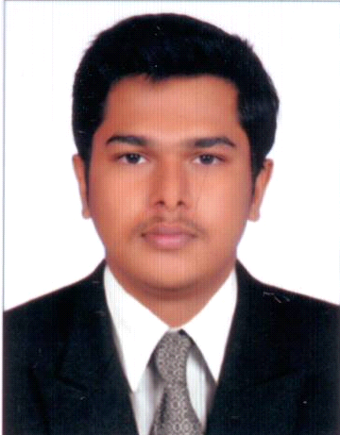

HARIKRISHNAN
E-mail: harikrishnan.370854@2freemail.com

OBJECTIVE :

With my academic, professional background and experience I will reduce supervision on me and added my part of work to the organization.

WORK EXPERIENCE :

- One Year experience in HDFC BANK LTD, Varkala as Sales Officer
- 10 Months experience in JIO Telecom Service Distribution as Office Staff
- One Year experience in Sun Direct DTH Sales & Service distribution centre Cherunniyoor as Promotion Staff.

ACADEMIC QUALIFICATIONS :

- High School:
Qualification obtained : S.S.L.C.
Year of Passing : 2009
Name of the Board : Public Board of Examination, Kerala
- Higher Secondary School:
Qualification obtained : Plus Two (Commerce)
Year of Passing : 2011
Name of the Board : Higher Secondary Board of Exam, Kerala
- Degree:
Qualification obtained : B.com with Hotel Management and Catering
Year of Passing : 2014
Name of the University : University of Kerala

COMPUTER KNOWLEDGE :

- Tally
- Basics of Networking

PERSONAL STRENGTHS :

- Hard working.
- Strong Decision
- Friendly
- Leadership Qualities

PERSONAL PROFILE :

Name : HARIKRISHNAN
Father’s Name : Ramesan
Age : 24
Date of Birth : 07Aug1993
Gender : Male
Religion : Hindu
Nationality : Indian
Marital Status : Single
Languages Known : English & Malayalam

DECLARATION
I hereby declare that the above mentioned information is true to my knowledge and bear the responsibility for the correctness of the above mentioned particulars.

Place : HARIKRISHNAN
Date :

