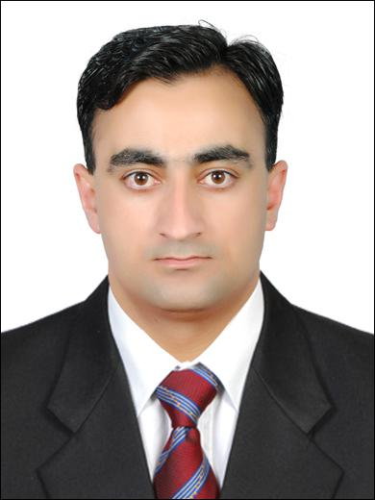

Ammad

E-mail: ammad.370878@2freemail.com
DateofBirth:19-11-1986
Nationality:Pakistani(NativeofKashmir)
MaritalStatus:Unmarried
VisaStatus:FreeZone
Languageknown:English,Hindi,Urdu,Punjabi,basicArabic
Height:5ft8inch
Weight:76kg

OBJECTIVE

Toobtainapositioninthecustomercarefieldthatutilizesmycurentandpreviousexp erienceinhandlingcustomerquiries,complainsandtrytosolvethemwhileworkingind ependentlywithlimitedornosupervision.

CERTIFICATEANDSKILLS

- DPSInternationalTrainingforSecurityPersonnelfromDubaiPoliceAcademy.
- PSBDfromNationalSecurityInstitute(NSI)AbuDhabi.
- Basiccomputercourse.(Microsoftoffice)
- CertificateofTeaching(CT)fromSkilDevelopmentCouncil.(PAK)
- Multilingual:cancommunicateinEnglish,HindiandUrdu.
- Result-orientedandorganized-.

- Extensiveknowledgeandexperienceinfindingthebestsolutionsforemergenc ysituations.

EXPERIENCE

InDubai

AlFajerSMS.

- WorkingSites

- SkyGardenDIFC(Residencetower)

SkyGardenTower,D.I.F.C,Dubai,U.A.E.withStrataGlobalManagement.
- Maintainingrecordofparcels,couriers,messages,mails,andlostandfoundprop
erty.

- Albuildinginformationpertainingtothenumberofavailableapartments,faciliti esoffered,andemergencyresponsesituationswereportrayedtopotentialtena nts.

- DaytonaBuilding,MotorCity(Officebuilding)

DaytonaBuildingMotorcity,Dubai,U.A.E.withPremiumCommunityManageme
nt.

- Answercustomercals,tendingtocustomerinquiriespolitelyandinatimelyma nner.

- WritingelectronicreportsdirectlytoFacilityManager.

- Providingassistancetostaffandvisitorsatthesite.

- Ensuringalrulesandregulationsareenforcedbyalvisitorsandstaff.

- Supervisingandenforcingthesystemof"identifyingandinspecting"personnel

ormaterials.
- Knowingalemergencynumbersandprocedures.

InAbuDhabi

ProfessionalSecuritySystem(PSS)

- CustomerCare,AccessControlandsafety.
- Observeworkingoffountains,travelators,esculators,elevatorsandLCD.
- Customersenquiriesregardinglostandfound.
- Maintaindailychecklist.

EDUCATION

- 2004to2006

IntermediateFsc(Bio,Chem,Phy)
- MirpurBoard,AzadKashmir,Pakistan
(DegreesareatestedfromIBCC,ForeginOfficeandUAEEmbassy)

