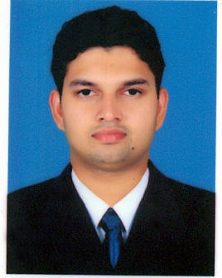
CURRICULUM VITAE

MUHAMMED
Mail ID: MUHAMMED.370956@2freemail.com
Career Objective

To be a part of accompany where hard work and can I dedication are highly recognized and in same way,will also help chance my capabilities and knowledge to develop more off what do for a mutullybenefical relationship with the company…

Personal Details

Name : MUHAMMED

Date of Birth : 04/06/1990
Nationality : Indian
Religion : Muslim
Gender : Male
Marital Status : Single
Languages Known : ENGLISH,MALAYALAM,TAMIL,HINDI

Academic Qualification

Qualification | Board/ University | % of Marks | Year of Passing
S S L C | Board of Public Examinations, Kerala | 60 | 2005
Plus Two commerce | Board of Higher Secondary Examination, Kerala | 74 | 2008
B.COM | SHOBHITH UNIVERSITTY | 86 | 2013

Professional Experience
- 1 Year Experience in BSNL as a custmar service in kerala (1 years)
- 4 years working (BLUE MART GROUP) in Dubai ( CASHIER)

KEY SKILLS

- Team management.
- Good leadership skills.
- Good motivator.
- Hard working.
- Disciplined

PASSPORT DETAILS

Place of Issue : MALAPPURAM
Date of Issue : 09/06/2011
Date of expiry : 08/06/2021

COMPUTER SKIILS

- M.S. Office
- Adobe Photoshop
- Video Editing
- Tally ERP
DRIVING LICENSE(UAE)
-PLACE OF ISSUE-DUBAI
DECLIARATION

I hereby declare that all the information and facts given above are true to best of my knowledge and that I am in possession of the documents in proof to the claim made in this resume.

