Ronald  Ronald.371014@2freemail.com | 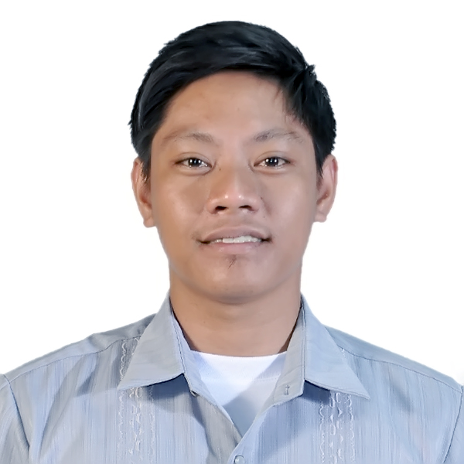

CAREER Objective

I am seeking with a company where I can use my talents and skills to grow and expand the company, and also I want to excel in this field with hard work, perseverance, and dedication.
To work in a stable company that will enhance my knowledge and capability for my career growth formation and becomes a well-rounded person.

Professional Experience
IT SPECIALIST / IT INSTRUCTOR - May 22, 2014 – May 31, 2017
LYCEUM OF APARRI (PRIVATE SCHOOL)
Macanaya Aparri, Cagayan | Philippines
Job Responsibilities:
- Maintain and update all the computer (Mostly server units)
- Troubleshooting of computers & repairing
- Encoder
- CCTV operator – Daily Monitoring
- Server maintenance of the Library (Online Public Access Catalog, E-library System, Internet Laboratory)
- Part time teaching during summer | Philippines

LIBRARY STAFF May 22, 2014 – May 31, 2017
LYCEUM OF APARRI (PRIVATE SCHOOL)
Macanaya Aparri, Cagayan | Philippines

Job Responsibilities:
- Coordinate and organize all the books inside the library
- Statistical monthly reporting
- Help my colleagues with the documents needed to prepare during accreditation.
- Manage multiple students and their queries
- Updating Newsletter using Microsoft Publisher
- Yearly books inventory

BFAR (BUREAU OF FISHERIES AND AQUATIC RESOURCES) | April – June 03, 2011
Region 2 Carig, Tuguegarao City
(On the Job Training)
Job Responsibilities:
- Assist in transactions of Purchase Order (PO) and Request Order (RO)
- Inventory and supplies data encoder (MS Excel)
- Filling of documents

EDUCATIONal background

LEVEL NAME OF THE SCHOOL

TERTIARY : LYCEUM OF APARRI | LEVEL IV ACCREDITED | PACUCOA (Philippine Association of Colleges and Universities Commision on Accreditation)
Bachelor of Science in Information Technology , March 2012

SECONDARY: LYCEUM OF APARRI (HIGH SCHOOL) | Philippines

ELEMENTARY: LYCEUM OF APARRI | Philippines

Additional Skills

- Computer networking
- Photo Editing-(Photoshop)
- Troubleshooting & Repairing of Computers
- Cellphone formatting
- Lan Cabling
- MS Office

STRENGTH

- Can work with minimum supervision
- Can work even at grave yard shift
- Competitive
- Have a dedication of work
- Simple, honest, loyal to a company

SEMINAR/TRAINING ATTENDED/CERTIFICATE

- COMPUTER SYSTEM SERVICING “CSS – NC2”
- Seminar – Workshop in Network Security
- YOUTH CAMP 2012 (PRESIDENT OF DEPARTMENT)
- IT Carrer Trends and Photo Editing Using Adobe Photoshop

PERSONAL BACKGROUND

AGE: 26
DATE OF BIRTH: OCTOBER 12, 1990
PLACE OF BIRTH: Aparri, Cagayan, Philippines
GENDER: Male
HEIGHT: 5’3”
WEIGHT: 65 kg
RELIGION: Roman Catholic
CIVIL STATUS: Single
CITIZENSHIP: Filipino

I hereby certify that all the above information is true and correct to the best of my knowledge skills and belief.

