NANDITA

Result-oriented professional with a proven record of achievement in conceiving & implementing effective ideas; targeting top level assignments in Admin. / Human Resources / Sales Coordination with a leading organization of repute in Banking / Hotel sector, preferably in GCC / Canada / Australia

Nandita.371017@2freemail.com

Key Skills

Admin.

HRM

Sales Coordination / Support

Strategy Planning

Recruitment & Selection

Reporting & Documentation

Process Improvement

Team Building & Leadership

Profile Summary

Dynamic career of 6 years that reflects rich experience & year-on-year success in Admin., HRM, Payroll, Recruitment, Sales
Support and Training:

o Leading the development, implementation, evaluation & modification of administrative policies & procedures to optimize resource & capacity utilization across various functions

- Steering the complete recruitment including evaluating required skills, identifying the possible sources, sourcing, screening & short-listing the candidates and negotiating & fitting them into system

Expertise in ERP based software for various HR and sales support functions

Proven skills in driving HR initiatives to realize bottom line results, realigning HR policies in the pursuit of objectives of leading organization & maintaining harmonious relations amongst employees to create an amicable environment

A forward thinking person with strong communication, multi-tasking, negotiation, analytical & organizational skills; well organized with a track record that demonstrates self-motivation & creativity to achieve corporate goals

Career Timeline

 | Thomas Cook as |  |  |  |  | V5 Global
 | Foreign Exchange |  |  |  |  | Services India as
 |  |  |  |  |  | HR Executive
 | Executive
 | Jun’09-Dec’09 |  | May’12-Dec’14 |  |  | Apr’14-Jan’15 |  | Jan’16-May’17
 |  |  | The Oberoi |  |  |  |  | National Bank of
 |  |  | Rajvilasas HR |  |  |  |  | Abu Dhabi as
 |  |  | Assistant |  |  |  |  | Admin. Officer

Soft Skills

Communicator Innovator

Thinker

Collaborator Intuitive

Education

MBA (Marketing & HR) from Banasthali Vidyapith, Jaipur in 2012 B.Sc. in Hospitality & Hotel Administration from IHM, Hyderabad in 2009

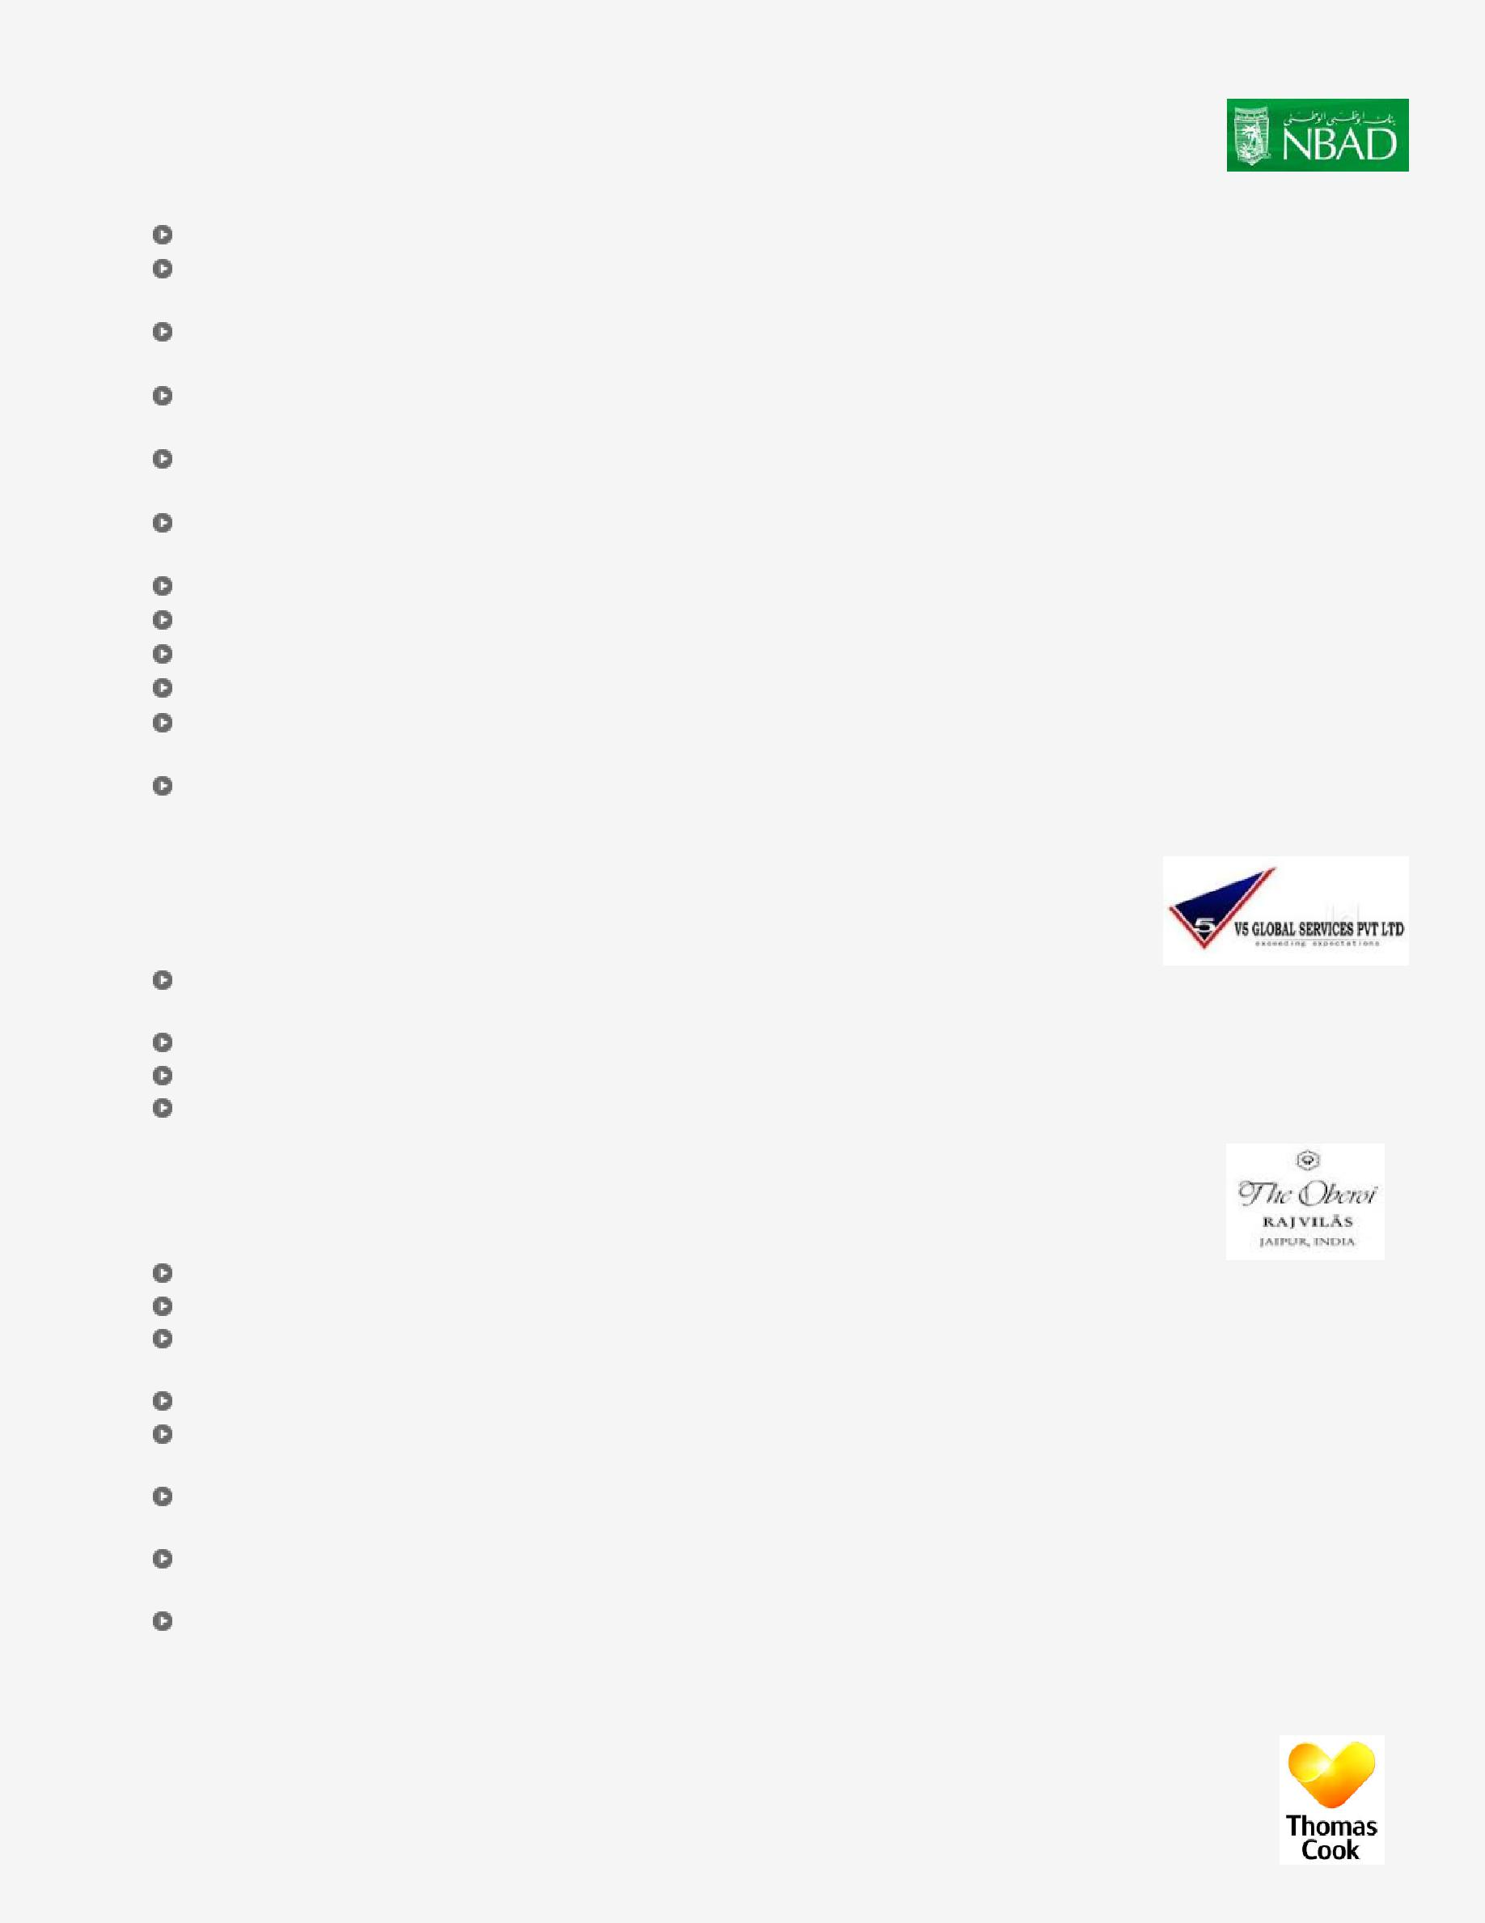
Work Experience

Jan’16-May’17: National Bank of Abu Dhabi, Abu Dhabi as Admin. Officer

Role:

Rendered support to supplementary credit card sales process and managed the revenue generation for bank

Liaised with Team Leaders every month to collect the monthly sales target achieved by sale of credit card products and compared it with the given target through reports in Excel Sheet

Interfaced with management & Head of Department to implement recruitment & HR policies for effective management of available resources & development of human capital across the organization

Sourced profiles by visiting job portals, candidate referrals, job posting & company database and screened CVs using both internal & external sources like job portals, referrals & recommendation and consultancy

Established & managed administrative activities including budgeting, housekeeping, transportation, security, and so on in cost effective manner to ensure departmental profitability thereby achieving business goals

Announced the policy change, new targets and any other organizational changes by senior management to employees through notification mails

Steered the consolidation of Annual Leaves Reconciliation File for all NBAD contact staff

Assisted senior management in all admin. functions and managing all HR related staff issues

Managed the staff recruitment and updating the headcount accordingly

Achieved financial objectives by anticipating requirements and submitting information for budget preparation

Maintained the continuity among divisions & local work teams by documenting & communicating actions, irregularities and continuing needs

Facilitated professional & technical knowledge by attending educational workshops, benchmarking professional standards, reviewing professional publications and establishing personal networks

Apr’14-Jan’15: V5 Global Services India, Delhi as HR Executive

Role:

Issued the online offer letters through ERP software and prepared Relieving, Authorization and Increment & Transfer Letter for employees using ESS software

Provided brief overview about the company, its work culture & policies and rendered training to new joiners Managed ESIC, documents, attendance / salary processing & joining and exit of employees

Led the management of payroll for various projects like Capdase, De’ longhi, Logitech, Funai and UEI

May’12-Dec’14: The Oberoi Rajvilas, Jaipur as HR Assistant

Role:

Led the management of recruitment and selection for the open positions Steered the marketing of the organization on social platforms

Prepared various reports like Fortnightly Report, Manpower Report and Human Resource Information System Report (HRIS)

Managed employee, contractors, apprentice, policy and various other HR related files

Worked on human resources programs like talent acquisition, health & welfare benefits, records management, safety & health, succession planning and employee relations & retention

Enhanced the manager & employee performance by identifying & clarifying problems, evaluating potential solutions, implementing selected solution and coaching & counseling managers & employees

Executed Special Projects by clarifying project objective, setting timetables & schedules, conducting research, developing & organizing information and fulfilling transactions

Ensured compliance with federal, state & local legal requirements by studying existing & new legislation, anticipating legislation, enforcing adherence to requirements and advising management on needed action

Previous Experience

Jun’09-Dec’09: Thomas Cook, Bangalore as Foreign Exchange Executive

Technical Skills

Forex Market, MS Office (Excel, PowerPoint & Word), Intellect Software, Access Plus & Vision Plus Software as well as ESS & ERP Software

Training

Training on SAP

Personal Details

Address: Navy Gate, Abu Dhabi
Languages Known: Hindi and English

