Gayatri

Gayatri.371019@2freemail.com

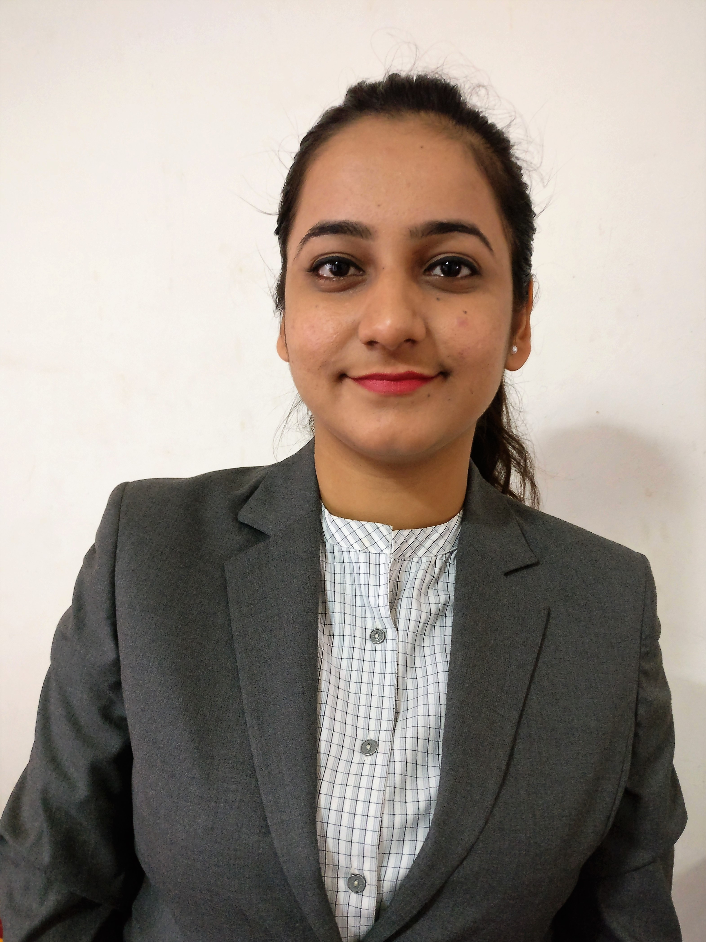

Synopsis:

- Self-motivated professional with over 7 years+ of experience in different fields, including Mortgage, financial analysis, Accounting & Sales.
- Analyzing risk for granting loan and allowing credit term to borrowers.
- Specialize in the analysis of credit worthiness of entities and individual for their borrowing requirements.
- Preparation of report and sending to the management.
Work Experience:

Company | XL Dynamics India Pvt. Ltd.
Job Title | Associate Analyst – Insuring
Duration | September 2014 to June 2017

Key Responsibilities:

- Preparing post-closing mortgage loan packages and submit to portal for Insuring and issuance of guarantee certificate as per agency and investors requirement. Having specialization in US Mortgage FHA (Federal Housing Administration) and VA (Veteran Affairs) loans.
- Detailed analysis and review of closing loan documents to verify that loan is closed in compliance to agency, investors and internal guidelines.
- Review of initial application (1003), ID proofs, online searches to mitigate any potential Red flag in file.
- Detailed review of state compliance documents to verify licensing requirements.
- Review of Tax certificates and Insurance policies (Hazard / Flood) to ensure coverage meets the requirements.
- Co-ordination with internal teams on missing information / documents to ensure timely insuring of loan file within given TAT.
- Worked with different teams which are involved in developing comprehensive and accurate understanding of risk analysis guidelines, Review the complete loan files i.e. credit history, available assets and liabilities to determine the risk associated with a Mortgage.
- Handling calls from internal parties and addressing queries related to insuring.
- Query resolution of fellow team members related to loan scenarios.
- Handling of team in absence of supervisor.
- Timely updating of checklists and Knowledge base in reference to guidelines.
- Daily assignment of tasks to team members.
- Providing team specific training to new joiners.
- Perform audit and quality check on work done by other team members and report issues to them and ensure corrective action are taken.
- Preparing Daily, Weekly, Quarterly and Monthly team productivity reports and sending them to management.

Achievements:
- Achieved 100% assigned daily targets with efficiency.
- Achieved zero error benchmark in work performed.
- Helped in identifying process gaps and fixing them resulting into reducing cost of company.
- Achieved 1st Rank in Team Quarterly performance based on productivity, efficiency and error rate.
Work Experience:

Company | First Advantage Pvt ltd
Job Title | Verification Associate (Employment Department)
Duration | July 2011 – December 2012

Key Responsibilities:

- Responsible for Verification of Candidates who has applied for jobs in different companies to our Clients.
- Placing calls and sending mails to HRs and VPs to get the verification done of candidates.
- Respond to requests, queries and complaints from Different HRs as well as to the team members in a friendly and efficient manner.
- To provide an effective and efficient information regarding candidates, ensuring the accurate and timely information delivery.
Work Experience:

Company | Sony India Pvt Ltd
Job Title | Sales Manager
Duration | December 2008 – January 2011

Key Responsibilities:

- Selling Laptops, Digi cams and Handy cams to various corporate clients by assessing their business requirements.
- Leading Sales & Marketing team also worked as mentor and gave guidance to interns.
- Achieving sales targets through acquisition of new clients and growing business from existing clients.
- Responsible for conducting business development activities, apart from lead generation as well as providing assistance to the Corporate and Retail customers.
- Handled sales team of 6 members, management of the team to ensure that each team member achieves monthly target, front office administration, dealing with high profile customers, handling customer services, solving complaints related to services, identify and pursue new business opportunities, market identification/penetration, selling & marketing of products, developing long term relations with customers and achieving monthly targets.
Work Experience:

Company | Acer India Pvt Ltd
Job Title | Accounting- General
Duration | October 2007 – November 2008

Key Responsibilities:

- Monitored customer payment discrepancies and reconciliation of accounts, Worked upon Tally ERP 9.0.
- Responsible for Account Receivables management for the assigned portfolio.
- Follow up with Customer several department for payment and look after the queries raised by them related to payment.
- Circulation of MIS to department head regarding payment collection, achievement, dealer wise outstanding report.
- To look after the opportunities to improve client processes and streamline work for the overall payment process.
- Identify missing invoices and support the efforts of the audit team to work with client teams to identify root causes for these missing invoices and implement corrective actions.

Professional Qualification:

Course | University | Name of Institution | Year of Passing
MMS (Master of Management Studies)  Specialization – Finance | Mumbai University | Sheila Raheja College of Business Management & Research, Mumbai | 2014
BMS (Bachelor of Management Studies) Specialization – Finance | Mumbai University | Viva College, Mumbai | 2011

Academic Projects:

2013

Organization : State Bank of India
Designation : Intern
Location : CST Fort (Mumbai)
Duration : 2 Months
Topic : Marketing of Point of Sale & Use of Technology Products.

2012

University : Mumbai University
Location : Mumbai
Duration : 1 Month
Topic : Working Women survey

Computer Skills:

- Operating Systems : Proficiency in Operating Windows
- Packages Known : MS Office (Word, PowerPoint, Excel), Proficiency in operating ERP system (SUNSOFT)

Extracurricular Activities:
- Won First prize at Inter school dance competition.
- Inter-School Silver Medal Award Winner for drawing competition.
- Inter-School Silver Medal Award Winner for Doug Ball competition.
Interests:
- Dancing, Travelling.

