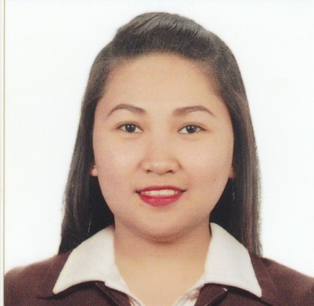
SUCCESS

SUCCESS.371040@2FREEMAIL.COM

PERSONAL INFORMATION
Age: 26 years old
Civil Status: Single
Nationality: Filipino
Place of Birth: Batac, Ilocos Norte
Languages or Dialect: English, Tagalog and Iloko

CAREER OBJECTIVE

To achieve high carrier growth through a continuous learning process and keep myself dynamic, visionary and competitive with the changing scenario of the world, while utilizing my educational and communication skills, to give the best quality service and demonstrate the competence that satisfies the interest of the company with the best use of my dedication and determination.

EDUCATIONAL BACKGROUND
Year Graduated
2012 Tertiary Level:
Mariano Marcos State University
Batac, Ilocos Norte
Degree: Bachelor of Arts in English Studies

2007 Secondary Level:
Pinili National High School
Darat, Pinili, Ilocos Norte
2003-2007

2003 Primary Level:
Badoc South Central School
Badoc, Ilocos Norte
1997-2003

SEMINARS and TRAININGS

April 4-29, 2011 On the Job Training
Norther Dispatch- Baguio City
News Writter

May 2-27, 2011 On the Job Training
CoreTV- Vigan City
Production Staff

February 26-27, 2010 Seminar Workshop on Short film Making
and Script Writing
Mariano Marcos State University-CAS Multimedia Center

March 2009 Research Forum
Mariano Marcos State University
College of Arts and Sciences- Audio Visual Room

March 2009 Debate Seminar
Mariano Marcos State University- Teatro Ilocandia

February 17, 2009 Public Speaking and Debate Seminar
Mariano Marcos State University
College of Arts and Sciences-Audio Visual Room

February 17, 2009 Multimedia Design Seminar
Mariano Marcos State University
College of Arts and Sciences- Audio Visual Room

September 25, 2009 Integrated Marketing Communication
“The Road show on IMC by PANAF”
Mariano Marcos State University-Teatro Ilocandia

WORK EXPERIENCE

Globe Telecoms
365 San Nicolas Ilocos Norte/ Hypermarket Laoag City
Retail Assistant
December 17, 2012 – July 31, 2013

SKILLS/ABILITIES/CHARACTERISTICS
•Good in communicating with others
•Computer Literate
•Hardworking, Patient and Easy to be with
•Willing to learn
• Dedicated to work

