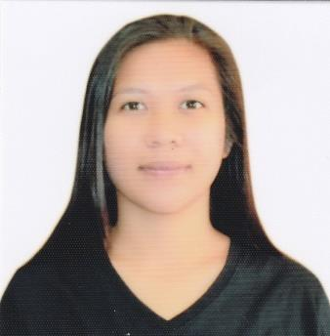
Name :ARNAIZ
Arnaiz.371043@2freemail.com

OBJECTIVE :
To be a part of company that indulges professional growth which provides challenging and rewarding career while allowing me to utilize my knowledge and skills.

EDUCATIONAL BACKGROUND :
Tertiary Level BS Respiratory Therapy 2012-2015
Cebu Doctors’ University
North Reclamation Area, Mandaue City
BS Accountancy 2011-2012
Ateneo de Naga University
Naga City
Secondary Level G. Bangalisan National High School 2007-2011
Burabod, Placer, Masbate
Primary Level Thomas M. Conde Central School 1998-2007
Centro, Placer, Masbate

WORK EXPERIENCED:
CUSTOMER SERVICE REPRESENTATIVE/TECHNICAL SUPPORT REPRESENTATIVE
Teleperformance Philippines
IT Building, Edsa Corner, Mandaluyong City, Philippines

SALES REPRESENTATIVE
BluConnect Solutions, Inc.
A.S. Fortuna St., Mandaue City, Philippines
November, 2012 – January, 2014

TRAININGS:
TESOL CERTIFICATE
TEFL INTERNATIONAL
Cebu City
December, 2016

AFFILIATION :
Cdt. Batl. S-3 C.A.T 2010-2011
G. Bangalisan National High School
Burabod, Placer, Masbate
Member Science Club 2009-2011
G. Bangalisan National High School
Burabod, Placer, Masbate
Member Math Club 2009-2011
G. Bangalisan National High School
Burabod, Placer, Masbate

SKILLS :
- Public Speaking – extemporaneous speech. Gain confidence and learned to engage audiences with my creative speech.
- Writing Skills – ability to efficiently produce concise, organized reports, labs and memos.
- Strong analytical and problem-solving skills.
- Systematic and highly detail oriented in Microsoft office and communication.

CHARACTER REFERENCES:

