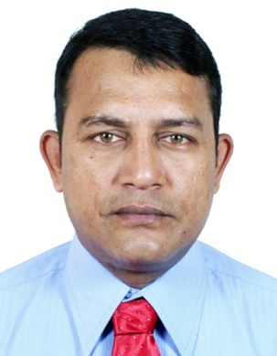
SANTO
SANTO.371063@2freemail.com
OBJECTIVE

Experienced cook actively seeking a position in the culinary field that will offer me the opportunity to continue to learn and develop my skill and help me realize my ultimate goal of becoming a master chef.
PERSONAL DETAILS

Date of Birth : 25th September, 1975
Other Interest : Taking photo and listening music
Language Known : English, Hindi, Bengali
Religion : Christian

WORKING EXPERIENCE

OBEROI FLIGHT KITCHEN, KOLKATA
Worked as a flight attendant of British Airways (1st July 2001 to 31st Dec 2001 )

HOTEL OBEROI GRAND, KOLKATA
Three years apprentice course in different section of food production.
(10th April 2002 to 9th April 2005)

HOTEL TAJ BENGAL, KOLKATA
Worked as a Commi II in continental Kitchen (16th May 2005 to 8th Sep 2005)

ASIAN GROUP OF HOTEL
Senior C.D.P at Palladian lounge, Kolkata at the Bengal chamber of commerce.
(7th November 2005 to 31st May 2006
CARNIVAL CRUISE LINE (USA)
As a Commi (2006 to 2009)
As a D.C.D.P (2009 to 2010)
As a C.D.P. (2010 to 2011)
As a Junior Sous Chef (2011 to 29th July 2013)
(31st July 2006 to 29th July 2013)

ASIAN GROUPS OF HOTELS
Worked with Palladian Lounge, Kolkata as Sous Chef from 31st July 2013 to 31st January 2 015
_____________________________________________________________________________________
TAMIMI GROUP OF COMPANY
Working with Emirates Oasis Catering, Dubai as a Assistant Chef, from 1st June 2016.
.
KEY QUALIFICATION

. Hands on experience in food preparation following prescribed menu recipes and preparation
Techniques.
. Well versed in assigning responsibilities to culinary staff.
. Able to create and maintain excellent relationships with the patrons and co-workers
. Experience with preparing and organizing Banquet as well as Restaurant meals
. Overseeing the day to day demands of the kitchen
. Maintaining the food quality for the customer
. Following the maintenance of cleanliness and hygiene in the kitchen
. Resolving customer complaints about the food

. Follow recipes in an order to maintain accuracy regarding proper proportions followed up by
Pre-platting food
. Assist Executive Chef in routine and additional task.

OTHER EXPERIENCE

Six months basic computer course from St. Xavier’s College Computer Centre, Kolkata
(Aug 24th 1993)
Completed Photography course from C.I.N.I. Institute Kolkata
(Feb 24th 1993)

ACEDEMIC QUALIFICATION

Year | Course | Name Of the Institution
1993 | Madhyamik (W.B.B.S.E) | St. Lawrence High School, Kolkata
1995 | Higher Secondary (W.B.C.H.S.E) | St. Lawrence High School, Kolkata
1997 | B.Com (incomplete) | St. Xavier’s College under  Calcutta University

STRENGTHS

- Ensured that customers are served well and effectively.
- Rotate products to avoid spoilage.
- Ambitious and highly motivated.
- Perform product inventory.
- Encourage the junior staff.
- Supervise the preparation and service food.

