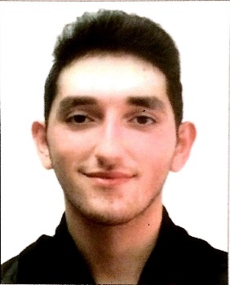
Atnas
Atnas.371068@2freemail.com

Short note about self
An enthusiastic, dedicated and versatile young person with an outstanding academic background and excellent attitude to work. Highly motivated, reliable with experience of working with an appealing personality, willing to
do his job in the best way possible.

Experience
Al Salam Cycle Tournament ▪9th March 2017
Mirage Concept ▪ Le Solarium Tower, Silicon Oasis
- Organizing and directing the crowd towards designated venues.
- Helping with the ending ceremony.
- Distributing promotional material to the crowd.
- Organizing the set and helping in maintaining it suitable for the crowd.

Promoter (Dragon Mart 2) ▪10th October-10th November
Mirage Concept ▪ Le Solarium Tower, Silicon Oasis
- Promotion of the newly opened mall.
- Responsible of tour guiding customers through the newly opened mall.

Laptops Promoter ▪ 25th May 2016 – 20th June 2017
- Responsible for working the sales floor and assisting customers with the product selections.
- Often called upon to assist customers who had complex questions or were unruly with their product demands.

Legal Translator
▪ 1st March 2016 – 31st March 2016
ZARCA Interactive ▪ Sheikh Zayed Road, City Tower 2
- Responsible of Translating Legal documents and reports to clients from English to Arabic and vice versa.
- Auditing and enhancing reports sent and received from clients.
- Responsible for writing professional letters to clients and suppliers.

Group Leader ▪ 1st May 2015 – 30th May 2015

Dubai Customs Main Office ▪ Port Rashid

- Organizing and Coordinating with Dubai Customs to have a successful awareness campaign about their new smart government initiatives.
- Communicating concepts and strategies clearly to colleagues.
- Prioritizing and sending follow-up letters.
- Assisting fieldwork, including interpretation.

Promoter (Dior) ▪ 1st April 2015 – 30th April 2015
AMS International ▪ Near Al Fahidi metro station
- Promoting the company’s image and products.
- Assisting with proof-reading, copying, packing, posting promotional materials.
- Achieving targets set by marketing managers.

Part-Time Call Center Interviewer & Supervisor.

1st September 2014 – 30th March 2015 & 1st June 2015 – 30th February 2016
Feedback Market Research ▪ Sharjah, Corniche Rd., Golden Tower.
- Working at the reception desk and dealing face to face with enquiries.
- Filing invoices and paperwork in relevant folders.
- Attended meetings with the company chartered accountants.
- Responsible for writing professional letters to clients and suppliers.
- Responsible of doing a quantitative research with clients.
- Involved in data entry of important statistical information.
- Having exposure to different industries, including automotive.

Skills
- Quick and accurate keyboard skills.
- Familiar with Microsoft Office.
- Able to speak and write English and Arabic fluently.
- Problem solving.
- Able to focus on accuracy and attention to details whilst under pressure and against deadlines.
- Ability to deal professionally but firmly with customers, including people older than
myself.
- Excellent organizational skills that allow me to multitask effectively.
- Adaptable to working in different locations at short notice.
- Able to communicate concepts and strategies clearly to colleagues.

Education

Al Dawha School
30th June 2014 ▪ American High School Diploma

Amity University Dubai
Nanotechnology (B. tech.) (Currently Studying)

References
Available on request.

