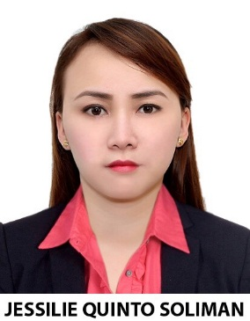
JESSILIE
JESSILIE.371084@2freemail.com
Registered Medical |Technologist (RMT)
American Society for Clinical Pathology (MLS- ASCPI)CM
HAAD LICENSED
Najda/Hamdan Street, Abu Dhabi, UAE
OBJECTIVE:
To seek employment that can offer an opportunity to learn, and continue to grow in knowledge and excel in innovative technology application of Medical Technology. To interact and share with group members and colleagues, and develop world class solutions to real world challenges.
BRIEF SELF DESCRIPTION:
I am a self-starter and a quick learner and have always abided by the rules and regulations the institute has provided.
WORK EXPERIENCE:
IBN NAFEES MEDICAL CENTER LABORATORY
August 30, 2015 to PRESENT
- Passed CAP and ISO accreditation for the laboratory (INMC LAB)

Consultants Medical Center
Medical Laboratory Technologist
June 2014 to August 29, 2015

San Fernandino Hospital Laboratory Department
Medical Technology Staff
October 5, 2005 to January 31, 2014

JOB DESCRIPTION:
Receive laboratory requests from patients, relatives, or nurses.
Identifying the right patient and collecting blood sample for the required test. Well trained in extraction of blood sample or phlebotomy.
Processing the specimen using Sysmex for Hematology, Vitros 350, COBAS E411 and COBAS INTEGRA for Chemistries, etc.¦ and knowledgeable in using other laboratory equipment and apparatus. Handling sections, Hematology, Chemistry, Clinical Microscopy, Blood Bank (crossmatching), Serology and Microbiology.
Analyzing and interpreting the results.
Releasing the result to the patient, relative or nurse’s station.
ASSOCIATED SKILLS:
• A trained phlebotomist
• Skilled in microscope, and other laboratory equipment and machine manipulation.
• Skilled in laboratory procedures concerning HEMATOLOGY, CLINICAL MICROSCOPY, CLINICAL CHEMISTRY, BACTERIOLOGY, SEROLOGY, and BLOOD BANK.
EDUCATION:
University of the Assumption Grade School
(1991-1997)
University of the Assumption High School
(1997-2001)
Angeles University Foundation
Bachelor of Science Medical Technology
2001 â 2005

LICENSURE & EXAMINATION PASSED:
Philippines Board Licensure Examination passer
American Society for Clinical Pathology Examination passer
HAAD Licensed
INTERNSHIP:
Veterans Memorial Medical Center (Pathology Department)
2004 - 2005
Other Skills:
Computer literate
Seminars Attended:
49th PAMET Annual Convention at PICC MANILA
PERSONAL INFORMATION:
BIRTHDATE: August 30 1984
PLACE OF BIRTH: City of San Fernando, Pampanga, Philippines
CITIZENSHIP:FILIPINO
Sex: Female
Civil Status: Single
Weight: 112lbs
Height: 5’3”
‘I hereby certify that the information written above is true and correct to the best of my knowledge and belief.”

